Unit-3: Digital Electronics

CONTENT

- Introduction to Digital Electronics
  - Need of Digital Electronics
  - Analog v/s Digital Signal

- Number System and Representation
  - Introduction
  - Binary to Decimal Conversion
  - Decimal to Binary Conversion
  - Binary to Hexadecimal Conversion
  - Decimal to Hexadecimal Conversion
  - Hexadecimal to Decimal Conversion
  - Octal to Decimal Conversion

- Basic and Universal Logic Gates
  - Introduction
  - Logic Addition
  - Logic Multiplication
  - Logic Gates
    - OR Gate
    - AND Gate
    - NOT Gate
    - NAND Gate
    - NOR Gate
    - EXOR Gate
    - EXNOR Gate

  - Logic Realization of Logic Gate Using Universal gates
    - Implementation of NOT, AND, OR, NOR, NAND, EX-OR, & EX-NOR Gate Using Universal gates

- Boolean Algebra Simplification of Boolean Function
  - Boolean Algebra
  - Laws of Boolean Algebra
  - Duality in Boolean Algebra
  - De Morgan’s Theorem
  - Boolean Algebra Theorems
  - Simplification of Boolean expressions
  - SOP and POS Representation for Logic Expressions

- Karnaugh map (K-Map)
  - Introduction
  - Rules of Minimization in K-Map
  - Two-Variable K-Map
  - Three-Variable K-Map
  - Four-Variable K-Map

Binary Arithmetic
- Complements
  - Subtraction using complements (1s & 2s)

Codes (Weighted and Non-weighted codes, BCD & Gray Code)

Sampling & Quantization in Digital Signal Processing

Fundamentals and Applications of Quantum Computing and Edge Computing

Summary
- Previously asked Questions in AKTU Exam
12.1. Short Answer Questions
12.2. Long Answer Questions
12.3. Numerical Problems

Model Questions (Theory & Numerical)

Prepared by: Mr. Hitesh Tomar

Reviewed by: Mr. Mudit Saxena
Note: Handouts provided are supplementary materials. Students are advised to refer the prescribed text and reference books for comprehensive understanding.

1. Introduction to Digital Electronics

Digital Electronics is the sub-branch of electronics that deals with digital signals for processing and controlling various systems and sub-systems. Digital electronics are the most common representation of Boolean algebra and are the basis of all digital circuits for computers, mobile phones, and numerous other consumer products. In various applications like sensors and actuators, usage of digital electronics is increasing extensively.

The most common fundamental unit of digital electronics is the logic gate. By combining numerous logic gates (from tens to hundreds of thousands) more complex systems can be created. The complex system of digital electronics is collectively referred to as a digital circuit.

1.1 Need of Digital Electronics

The more accurate representation of the digital signal can be generated using more binary digits and has a unique way of representation. With the support of computer handled digital systems, trending functions can be fed to software revision and required no changes in hardware. Moreover, the immunity to noise in the digital system allows the data to be retrieved and stored without any degradation. In an analog system, the aging noise may vary due to wear and tear properties in the stored information. But in digital, if the noise is below the suggested level, the data can be restored perfectly. Even if there is any presence of significant noise, the redundancy use allows the restoring of actual data and provides a strong resistance to errors.

1.2 Analog vs Digital Signal

Almost all the signals in the World are analog i.e. they are continuously varying values. There are lots of continuously variable signals or simply analog signals in nature like light, motion, sound, temperature, pressure etc.

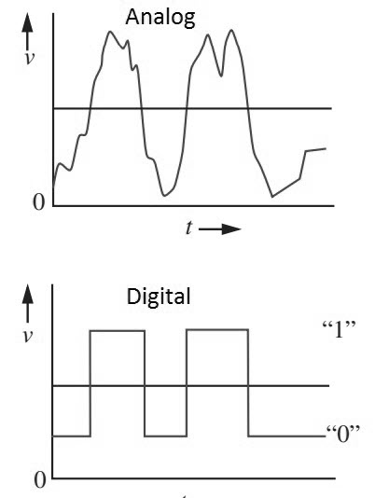

Figure 1.1 Representation of analog and digital signal

Digital Signals vary in discrete levels, in contrast to the continuous representation of analog signals. Generally, the discrete levels in a digital signal are just two values: ON and OFF. Even though all the physical signals of the nature are continuous analog signals, representing signals as discrete values has its own advantages.

Traditionally, all electronic devices processed analog information only. But, the development in technology has led to using digital signals for easy processing and such techniques are called Digital Signal Processing.

2. Number System and Representation

Introduction

In digital electronics, the number system is used for representing the information. The number system has different bases and the most common of them are the decimal, binary, octal, and hexadecimal. The base or radix of the number system is the total number of the digit used in the number system.

Table 2.1. Characteristics of Commonly used Number Systems
Number  System | Base or radix(b) | Symbols used  (d_{i} or d_{-j}) | Weight assigned to position |  | Example
Number  System | Base or radix(b) | Symbols used  (d_{i} or d_{-j}) | i | -j | Example
Binary | 2 | 0,1 | 2^{i} | 2^{-j} | 1101.11
Octal | 8 | 0,1,2,3,4,5,6,7 | 8^{i} | 8^{-j} | 3647.53
Decimal | 10 | 0,1,2,3,4,5,6,7,8,9 | 10^{i} | 10^{-j} | 3874.65
Hexadecimal | 16 | 0,1,2,3,4,5,6,7,8,9, A, B, C, D, E, F | 16^{i} | 16^{-j} | 4DAC.54

Binary to Decimal Conversion
Conversion of binary to decimal (base-2 to base-10) numbers and back is an important concept to understand as the binary numbering system forms the basis for all computer and digital systems.
Examples:
- Convert binary (10101)2 to decimal.

Solution:

10101B = 1×2⁴+0×2³+1×2²+0×2¹+1×2⁰ = 16+4+1= 21
- Convert binary (10110.001)₂ to decimal.
Solution:
First, multiply each bit of (10110.001)₂ with its respective positional weight, and then we add the products of all the bits with its weight.
(10110.001)₂=(1×2⁴)+(0×2³)+(1×2²)+(1×2¹)+(0×2⁰)+(0×2⁻¹)+(0×2⁻²)+(1×2⁻³)
(10110.001)₂=(1×16)+(0×8)+(1×4)+(1×2)+(0×1)+ (0×1⁄2)+(0×1⁄4)+(1×1⁄8)
(10110.001)₂=16+0+4+2+0+0+0+0.125
(10110.001)₂=(22.125 )₁₀

Decimal to Binary Conversion
For converting decimal to binary, there are two steps required to perform, which are as follows:
- Divide the given number by 2.
- Get the integer quotient for the next iteration.
- Get the remainder for the binary digit.
- Repeat the steps until the quotient is equal to 0.

Examples:

- Convert (13)10 to binary:

Solution:

Division by 2 | Quotient | Remainder
13/2 | 6 | 1(LSB)
6/2 | 3 | 0
3/2 | 1 | 1
1/2 | 0 | 1(MSB)

So, (13)10 = (1101)2
- Convert (152.25)₁₀ to binary

Solution:
Step 1: Divide the number 152 and its successive quotients with base 2.

Divide by 2 | Quotient | Remainder
152/2 | 76 | 0 (LSB)
76/2 | 38 | 0
38/2 | 19 | 0
19/2 | 9 | 1
9/2 | 4 | 1
4/2 | 2 | 0
2/2 | 1 | 0
1/2 | 0 | 1(MSB)
(152)₁₀=(10011000)₂
Step 2: Now, perform the multiplication of 0.25 and successive fraction with base 2.
Operation | Result | carry
0.25×2 | 0.50 | 0
0.50×2 | 0 | 1
(0.25)₁₀=(.01)₂
So, (152.25)₁₀ = (10011000.01)₂

Binary to Hexadecimal Conversion
The base numbers of binary and hexadecimal are 2 and 16, respectively. In a binary number, the pair of four bits is equal to one hexadecimal digit. There are also only two steps to convert a binary number into a hexadecimal number which are as follows:
- In the first step, we have to make the pairs of four bits on both sides of the binary point. If there will be one, two, or three bits left in a pair of four bits pair, we add the required number of zeros on extreme sides.
- In the second step, we write the hexadecimal digits corresponding to each pair.

Examples:

- Convert binary (1101100)2 to hexadecimal.
Solution:
Convert every 4 binary bits (starting from LSB) to hex digit i.e.
6

11011002 = 0 1 1 0 1 1 0 0 = 6 C = (6 C)16
C

Note: In the above example, the left side of the binary point has only three bits. To make it a complete pair of 4 bits, add one zero on the extreme side.
Table 2.2. Reference table for binary to hexadecimal equivalent

Binary ( )₂ | Hex Equivalent ( )₁₆
0000 | 0
0001 | 1
0010 | 2
0011 | 3
0100 | 4
0101 | 5
0110 | 6
0111 | 7
1000 | 8
1001 | 9
1010 | A
1011 | B
1100 | C
1101 | D
1110 | E
1111 | F

- Convert binary (10110101011.0011)₂ to hexadecimal.

Solution:
Firstly, make pairs of 4 bits on both sides of the binary point.
111 1010 1011.0011
On the left side of the binary point, the first pair has three bits. To make it a complete pair of four bits, add one zero on the extreme side i.e.
0111 1010 1011.0011
Now, write the hexadecimal digits correspond to each pair 4-bit pair i.e.
(0111 1010 1011.0011)₂= (7AB.3)₁₆

Decimal to Hexadecimal Conversion
For converting decimal to hexadecimal, there are two steps required to perform, which are as follows:
- Divide the number by 16.
- Get the integer quotient for the next iteration.
- Get the remainder for the hex digit.
- Repeat the steps until the quotient is equal to 0.

Examples:

- Convert (7562)10 to hex

Solution:

Division by 16 | Quotient  (integer) | Remainder  (decimal) | Remainder  (hex)
7562/16 | 472 | 10 | A
472/16 | 29 | 8 | 8
29/16 | 1 | 13 | D
1/16 | 0 | 1 | 1

So, (7562)10 = (1D8A)16

- Convert (152.25)10 to hex

Solution:

First, divide the number 152 and its successive quotients with base 16.
Operation | Quotient | Remainder
152/16 | 9 | 8
9/16 | 0 | 9
(152)₁₀=(98)₁₆
Now, perform the multiplication of 0.25 and successive fraction with base 16.
Operation | Result | carry
0.25×16 | 0 | 4
(0.25)₁₀=(4)₁₆
Hence, the hexadecimal number of the decimal number (152.25)₁₀ is (230.4)₁₆.

Hexadecimal to Decimal Conversion
A regular decimal number is the sum of the digits multiplied with power of 10. For example, (137)₁₀ is equal to each digit multiplied with its corresponding power of 10, i.e.
(137)₁₀ = 1×10²+3×10¹+7×10⁰ = 100+30+7.
Likewise, hex numbers are read the same way, but each digit counts power of 16 instead of power of 10.
For hex number with n digits, i.e. dn-1 ... d3 d2 d1 d0

Multiply each digit of the hex number with its corresponding power of 16 and sum:

Hence, decimal = dn-1×16^{n-1} + ... + d₃×16³ + d₂×16² + d₁×16¹+d₀×16⁰

Examples:

- Convert (E7A9)₁₆ to decimal

Solution:

E7A9 in base 16 is equal to each digit multiplied with its corresponding 16^{n} i.e.

E7A916 = 14×16³+7×16²+10×16¹+9×16⁰ = 57344+1792+160+9 = 5930510
Hence, (E7A9)₁₆ = (59305)₁₀
- Convert (3B)₁₆ to decimal

Solution:

3B in base 16 is equal to each digit multiplied with its corresponding 16^{n} i.e.

3B16 = 3×16¹+11×16⁰ = 48+11 = 5910

Hence, (3B)₁₆ = (59)₁₀

- Convert (152A.25)₁₆ to decimal

Solution:
First, multiply each digit of 152A.25 with its respective positional weight, and then we add the products of all the bits with its weight.
(152A.25)₁₆=(1×16³)+(5×16²)+(2×16¹)+(A×16⁰)+(2×16⁻¹)+(5×16⁻²)
(152A.25)₁₆=(1×4096)+(5×256)+(2×16)+(10×1)+(2×16⁻¹)+(5×16⁻²)
(152A.25)₁₆=4096+1280+32+10+(2×1⁄16)+(5×1⁄256)
(152A.25)₁₆=5418+0.125+0.125
(152A.25)₁₆=5418.14453125₁₀
Hence, (152A.25)₁₆= (5418.14453125)₁₀

Octal to Decimal Conversion

The process starts from multiplying the digits of octal numbers with its corresponding positional weights. And lastly, we add all those products.

Example:

Convert (152.25)₈ to decimal

Solution:
First, multiply each digit of 152.25 with its respective positional weight, and then we add the products of all the bits with its weight.
(152.25)₈=(1×8²)+(5×8¹)+(2×8⁰)+(2×8⁻¹)+(5×8⁻²)
(152.25)₈=64+40+2+(2×1⁄8)+(5×1⁄64)
(152.25)₈=64+40+2+0.25+0.078125
Hence, (152.25)₈=106.328125

3. Basic and Universal Logic Gates

3.1 Introduction

Logic gates are the basic building blocks of any digital system. It is an electronic circuit having one or more than one input and only one output. The relationship between the input and the output is based on certain logic. Based on this, logic gates are named as AND gate, OR gate, NOT gate etc. Moreover, NAND and NOR gates are called universal logic gates.
3.2 Logic Addition
The possible input and output combinations may be arranged as follows:
0 + 0 =0
0 + 1 =1
1 + 0 =1
1 + 1 =1

3.3 Logical Multiplication

We can define the "." (logical multiplication) symbol or AND operator by listing all possible combinations for (input) variables let say X and Y and the resulting (output) value of X.Y will be as follows:
Y
X
0.0 = 0
0.1 = 0
1.0 = 0
1.1 = 1
3.4 Logic Gates

- A logic gate is defined as an electronics circuit with two or more input signals and one output signal.

- AND, OR & NOT gates are called basic logic gates.

- NAND and NOR gates are called universal logic gates.

3.4.1 OR Gate

 | 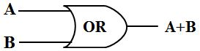
  Inputs |  | Output
  A | B | Y= A*B
  0 | 0 | 0
  0 | 1 | 1
  1 | 0 | 1
  1 | 1 | 1

3.4.2 AND Gate

 | 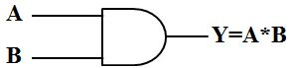
  Inputs |  | Output
  A | B | Y= A*B
  0 | 0 | 0
  0 | 1 | 0
  1 | 0 | 0
  1 | 1 | 1

3.4.3 NOT Gate

 | 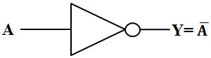
  Input | Output
  A | Y
  0 | 1
  1 | 0

3.4.4 NAND Gate

 | 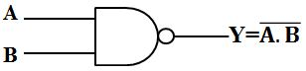
  Inputs |  | Output
  A | B | Y=$\overline{A.B}$
  0 | 0 | 1
  0 | 1 | 1
  1 | 0 | 1
  1 | 1 | 0

3.4.5 NOR Gate

 | 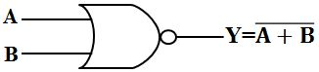
  Inputs |  | Output
  A | B | Y=$\overline{A+B}$
  0 | 0 | 1
  0 | 1 | 0
  1 | 0 | 0
  1 | 1 | 0

3.4.6 EX-OR Gate

Inputs |  | Output
A | B | Y=$A⨁B$
0 | 0 | 0
0 | 1 | 1
1 | 0 | 1
1 | 1 | 0

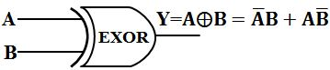

3.4.7 EX-NOR Gate

Inputs |  | Output
A | B | Y=$\overline{A⨁B}$
0 | 0 | 1
0 | 1 | 0
1 | 0 | 0
1 | 1 | 1

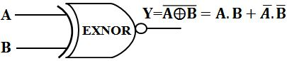

3.5 Realization of Logic Gate Using Universal gates

In Boolean Algebra, the NAND and NOR gates are called universal gates because any digital circuit can be implemented by using any one of these two i.e., any logic gate can be created using NAND or NOR gates only.

3.5.1 Implementation of NOT, AND, OR, NOR, NAND, EX-OR, & EX-NOR Gate Using Universal gates

Implementation Using Minimum Number of NAND Gates

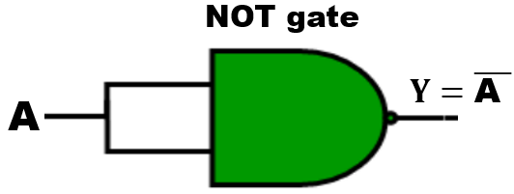 | 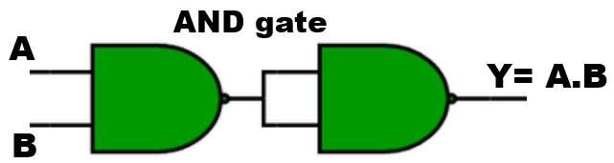
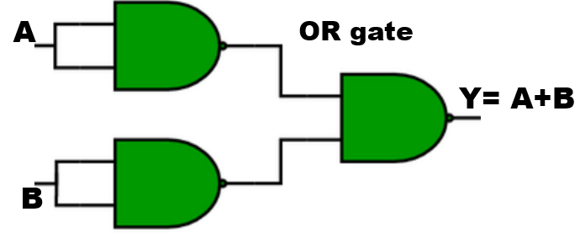 | 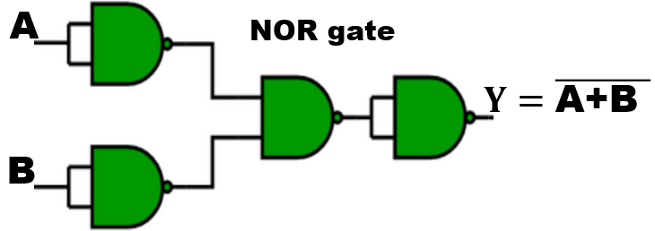
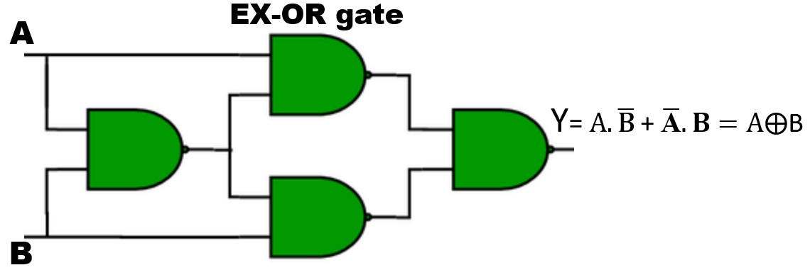 |  | 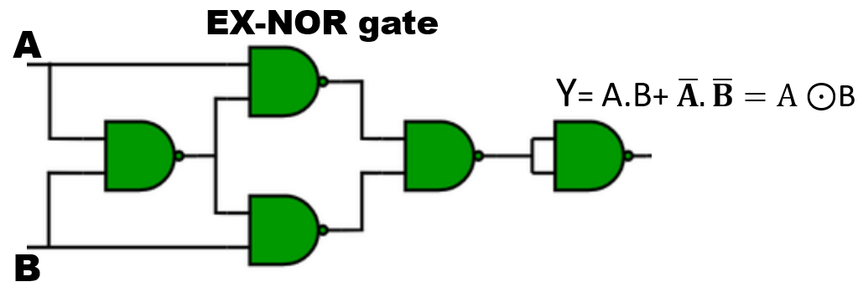

Implementation Using Minimum Number of NOR Gates

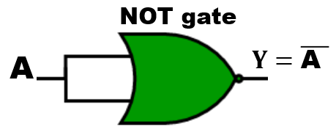 | 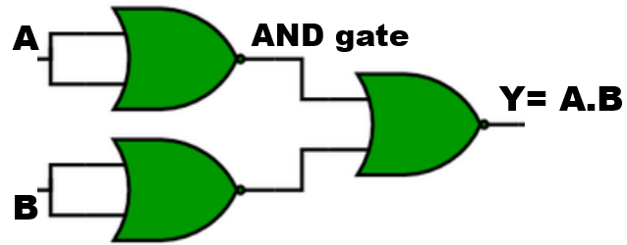
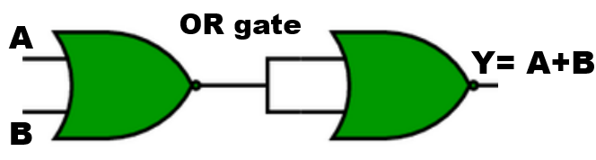 | 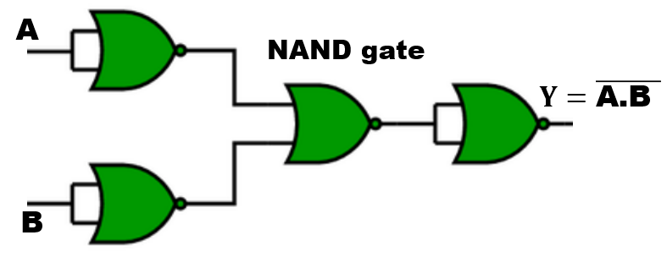
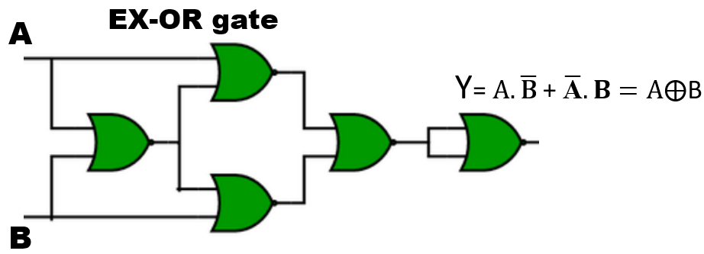 | 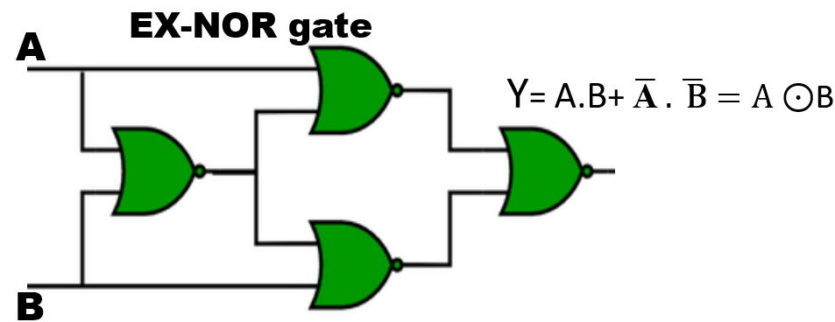

4. Boolean Algebra Simplification of Boolean Function

4.1 Boolean Algebra

An algebra which deals with the binary number system called Boolean Algebra. Here, we use logic gate concept i.e.

‘ + ’ Addition OR Gate

‘ ’ Multiplication AND Gate

4.2 Laws of Boolean Algebra

- Commutative Law
- Associative Law
- Distributive Law

- Commutative Law
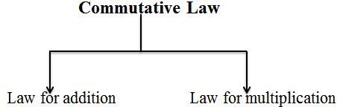

  - Law for addition
It is independent of order, this means if we change the sequence of variables, result will be same i.e.

A+B = B+A

 | = | 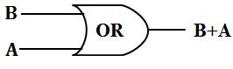

  - Law for multiplication

It is also independent of order. It means changing variable sequence while AND operation, the final result will not affect i.e.
A.B = B.A

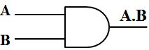 | = | 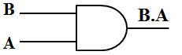

- Associative Law

  - Law for addition

Associative law for addition can be justified as follows:

A + (B+C) = (A + B) + C

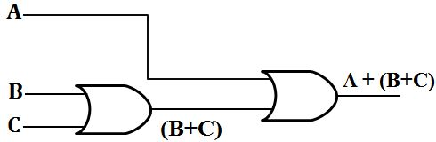 | = | 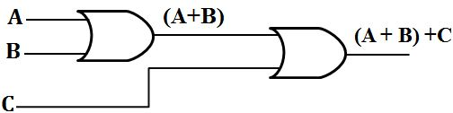

  - Law for multiplication

Associative law for multiplication can be justified as follows:
A. (B. C) = (A. B) .C

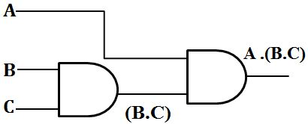 | = | 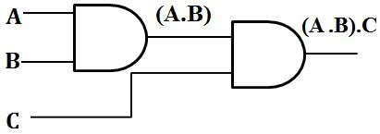

- Distributive Law

  - Law using AND operator

Distributive law using AND operator can be justified as follows:
A. (B+C) = A.B + A.C

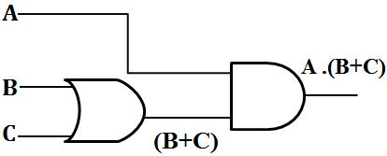 | = | 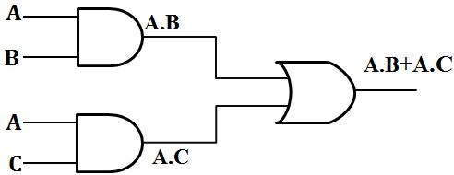

  - Law using OR operator

Distributive law using OR operator can be justified as follows:
A + (B.C) = (A+B).(A+C)

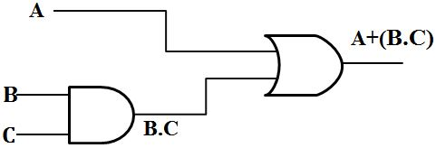 | = | 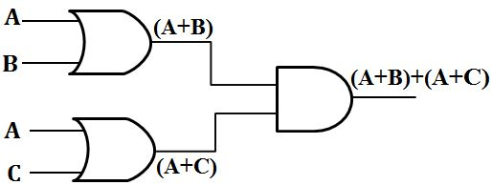

4.3 Duality in Boolean Algebra

Starting with a Boolean relation, we can derive another Boolean relation by-
- Changing each OR (+) sign to an AND (.) sign
- Changing each AND (.) sign to an OR (+) sign
- Complementary each 0 and 1

For example:

A + 0 = A

The dual relation is A.1 = A

Since, A (B + C) = AB + AC (by distributive law).

Its dual relation is A + B C = (A + B) (A + C)

4.4 De Morgan’s Theorem

This theorem can be justified as follows:
- $\overline{A+B}= \overline{A} . \overline{B}$

- $\overline{A . B}= \overline{A}+ \overline{B}$

4.5 Boolean Algebra Theorems

Name | AND Form | OR Form
Identity Law | A.1 = A | A+0 = A
Null Law | A.0 = 0 | A+1 = 1
Idempotent Law | A.A = A | A+A = A
Inverse Law | A.$\overline{A}$ = 0 | A+$\overline{A}$ = 1
Commutative Law | AB=BA | A+B=B+A
Associative Law | (AB)C= A(BC) | (A+B)+C= A+(B+C)
Distributive Law | A+BC=(A+B)(A+C) | A(B+C) = AB+AC
Absorption Law | A(A+B)=A | A+AB=A
De Morgan’s Law | $$\overline{A.B}= \overline{A}+\overline{B}$$ | $$\overline{A+B}= \overline{A}.\overline{B}$$

4.6 Simplification of Boolean expressions

In this section, we will discuss some working examples to simplify different Boolean expressions.

Example 1:

Simplify the Boolean expression $AB\overline{C}\overline{D}+AB\overline{C}D+ABC\overline{D}+ABCD$.

Solution:

Given, $AB\overline{C}\overline{D}+AB\overline{C}D+ABC\overline{D}+ABCD$

$AB\overline{C}\left(\overline{D}+D\right)+ABC (\overline{D}+D)$

$AB\overline{C}.1+ABC.1$ ; (As we know $D+\overline{D}=1$)

$AB\overline{C}+ABC$

$AB(\overline{C}+C)$

Hence, the answer is AB

Example 2:

Simplify the Boolean expression$AB(\overline{A} B \overline{C}+A \overline{B} \overline{C}+\overline{A} B C)$.

Solution:

Given, $AB(\overline{A} B \overline{C}+A \overline{B} \overline{C}+\overline{A} B C)$

$A \overline{A} B B \overline{C}+A A B \overline{B} \overline{C}$ + $\overline{A} A B B C$

$0 +0$ + 0 ; (As we know $A \overline{A}=0$)

Hence, the final answer is 0

Example 3:

Simplify the Boolean expression $(\overline{A} \overline{B}+A B+\overline{A} B )$.

Solution:

Given, $(\overline{A} \overline{B}+A B+\overline{A} B )$

$\overline{A} \overline{B}+B(A+\overline{A})$

$\overline{A} \overline{B}+B$.1

$B$ $+ \overline{A} \overline{B}$

$(B$ $+ \overline{A} )(B+\overline{B}$)

$(B$ $+ \overline{A} ).1$

Hence, the answer is $\overline{A} + B$

Example 4:

Simplify the Boolean expression $\left(A+B\right)(A+\overline{B})$.

Solution:

Given, $\left(A+B\right)(A+\overline{B})$

$A.A+A.\overline{B}+A.B+B.\overline{B}$
$A.A+A(\overline{B}+B)+0$

$A.A+A\left(\overline{B}+B\right)$

A + A

Hence, the answer is A

Example 5:

Simplify the Boolean expression $AB+A(C D+C \overline{D})$.

Solution:

Given, $AB+A(C D+C \overline{D})$

$AB+AC(D+\overline{D})$

$AB+AC.(1$)

Hence, the answer is $A(B+C)$

Example 6:
Simplify the Boolean expression $(B\overline{ C}+\overline{A} D)(A \overline{B}+C \overline{D})$.

Solution:

Given, $(B\overline{ C}+\overline{A} D)(A \overline{B}+C \overline{D})$

$$B\overline{ C} A \overline{B}+ B\overline{ C} C \overline{D}+\overline{A} D A \overline{B}+ \overline{A} D C\overline{ D}$$

$$B \overline{B }\overline{ C} A + \overline{ C} C B\overline{ D}+\overline{A} A D \overline{B}+ \overline{A} C D\overline{ D}$$

$0 + 0+0+ 0$= 0
Hence, the answer is 0
4.7 SOP and POS Representation for Logic Expressions

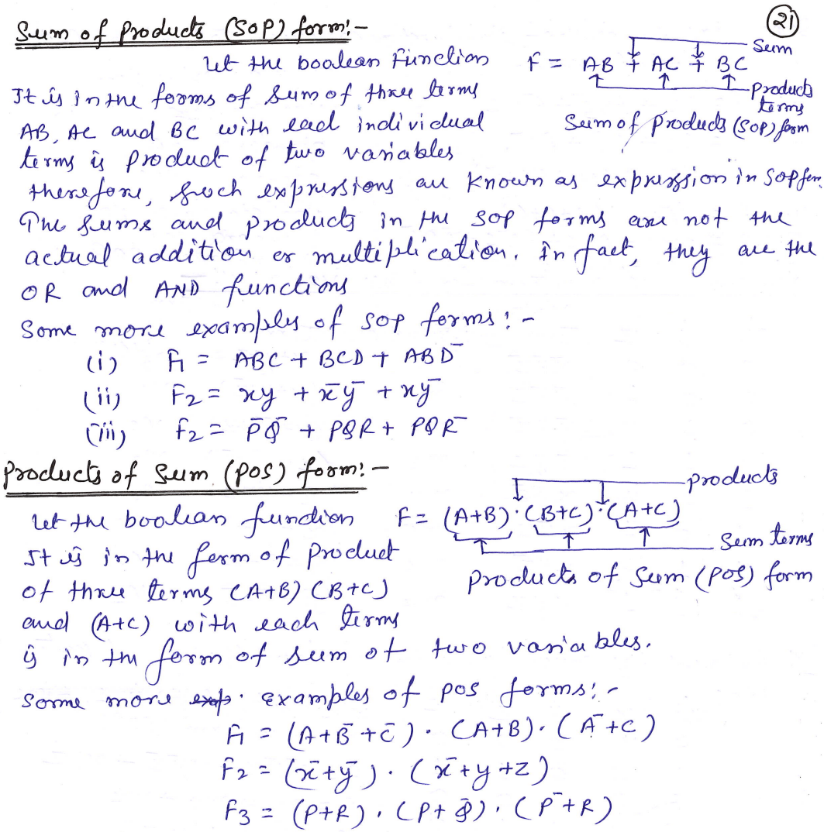

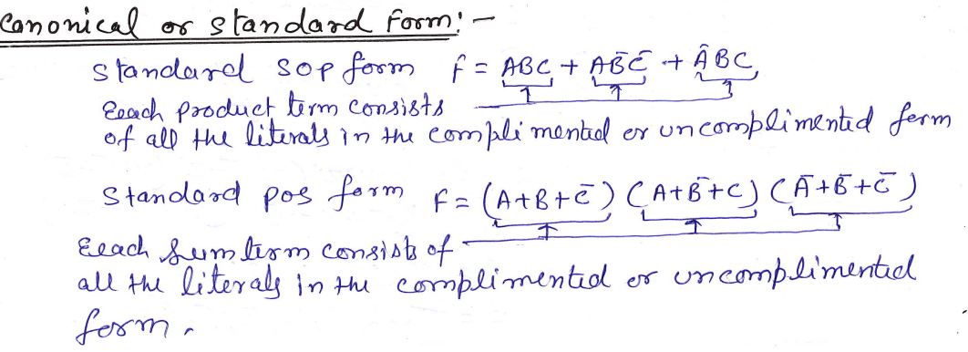

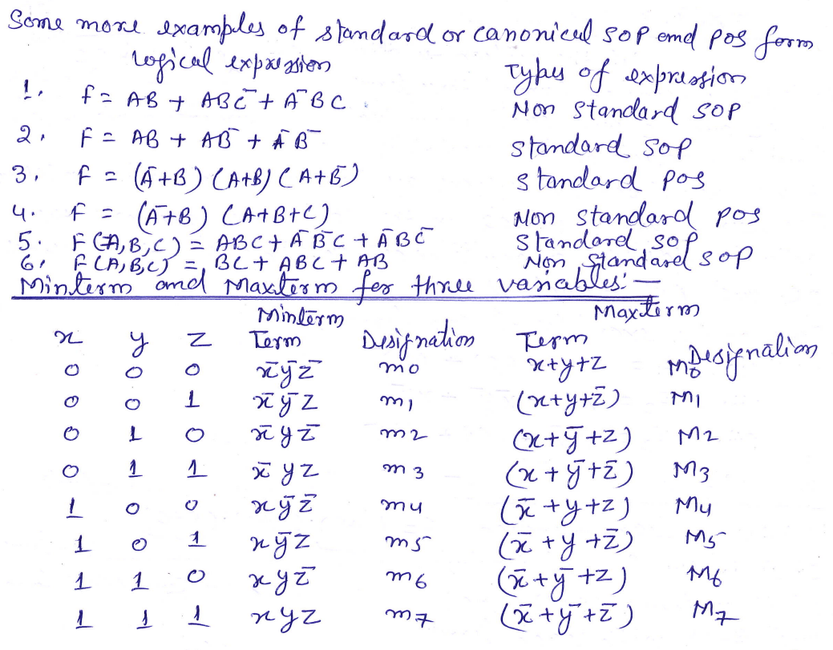

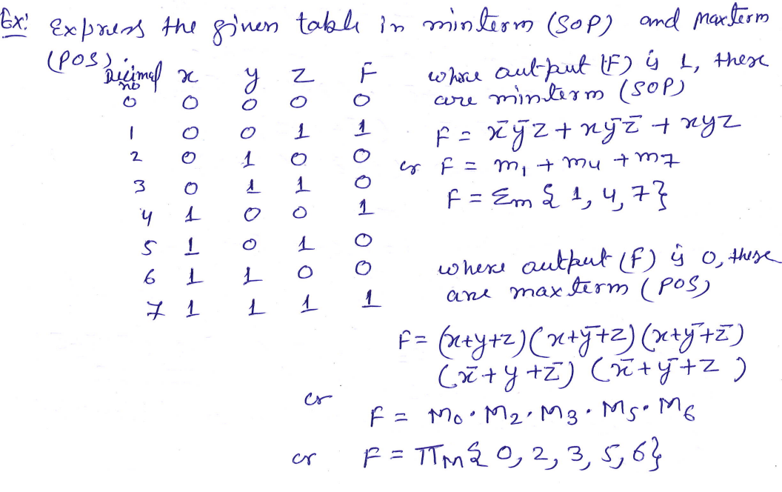
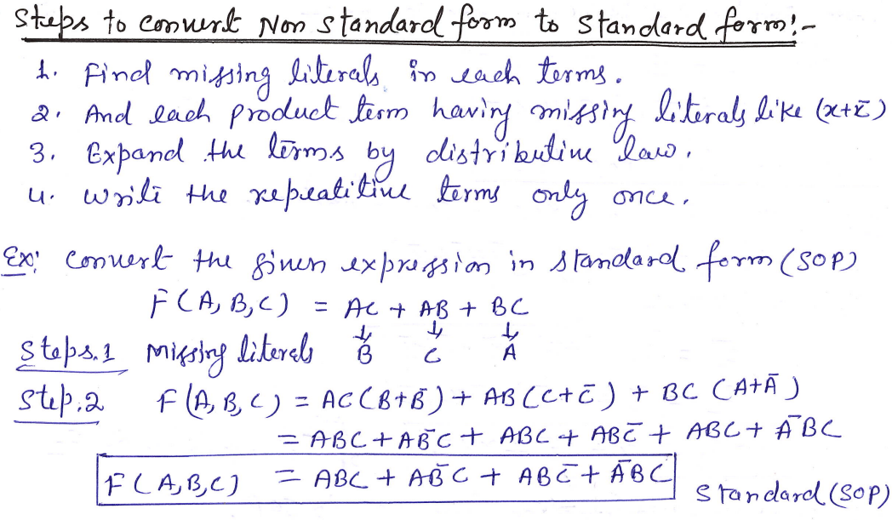

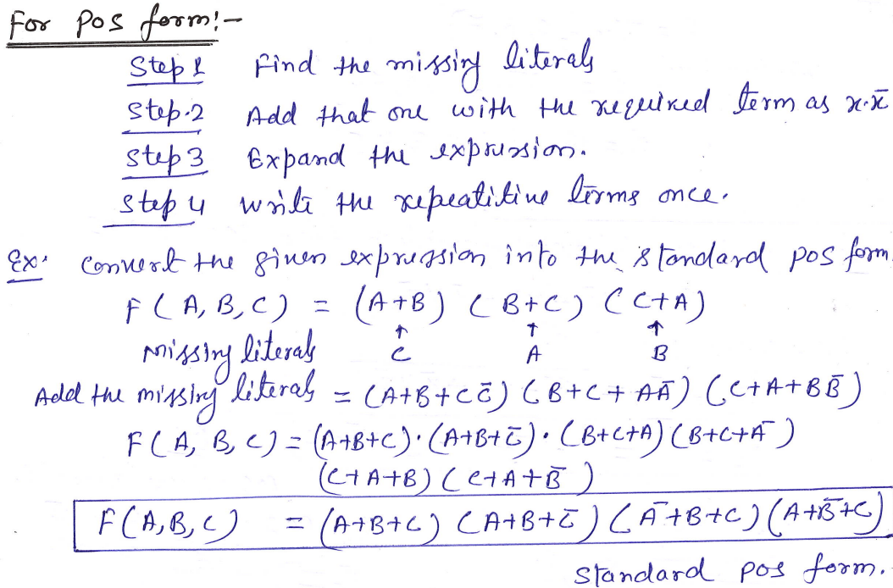
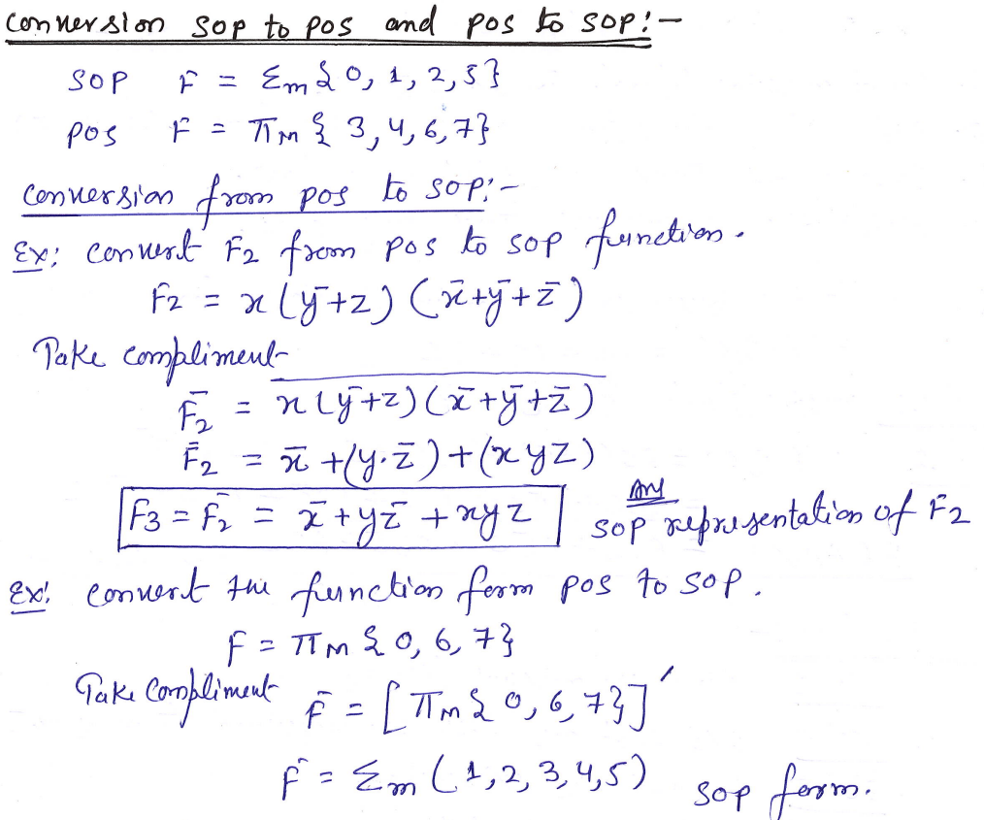
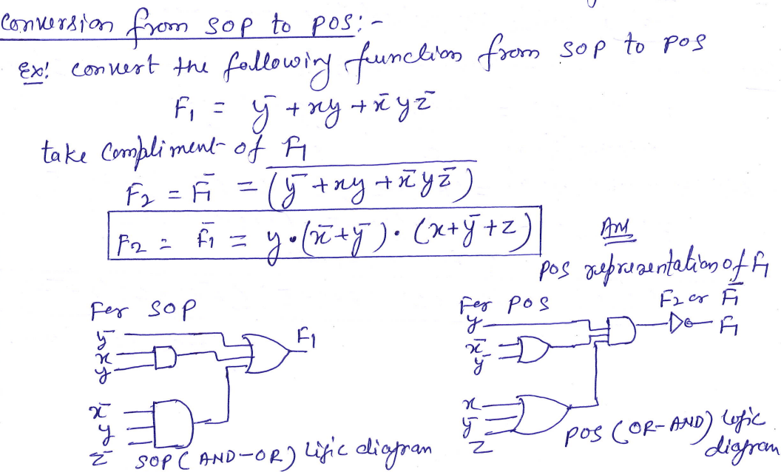

5. Karnaugh map (K-Map)

5.1 Introduction
Karnaugh map or K-map is a map of a function used in a technique used for minimization or simplification of a Boolean expression. It results in less number of logic gates and inputs to be used during the fabrication.

5.2 Rules of Minimization in K-Map
- While grouping, you can make groups of 2^{n} number where n=0, 1, 2, 3…
- You can either make groups of 1’s or 0’s but not both.
- Grouping of 1’s lead to Sum of Product form and Grouping of 0’s lead to product of Sum form.
- While grouping, the groups of 1’s should not contain any 0 and the group of 0’s should not contain any 1.’
- Groups can be made vertically and horizontally but not diagonally.
- Groups made should be as large as possible even if they overlap.
- All the like term should be in a group even if they overlap.
- Uppermost & lowermost squares can be made into a group together as they are adjacent (1-bit difference). Same goes for the corner squares.
- Each group represents a term in the Boolean expression. Larger the group, smaller and simple the term.
- The product of those literals that remains unchanged in a single group makes the term of the expression.
- Don’t care “x” should also be included while grouping to make a larger possible group.

5.3 2-Variable K-Map
2 variables have 2^{n} = 2² = 4 minterms. Therefore, there are 4 cells (squares) in 2 variable K-map for each minterms.
Consider A & B as two variables.
Grouping in 2 variables K-map is easy as there are few squares shown below
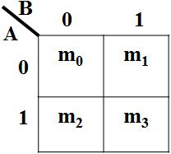

Example of 2 Variable K-Map-
F = ∑ (m₀, m₁, m₂) = A̅B̅ +A̅B +AB̅
Now, K-map from Truth table
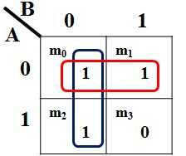
Hence, the simplifies expression will be the sum of these two terms as given below,
F = A̅ + B̅

5.4 3-Variable K-Map

- variables make 2^{n}=2³=8 min terms, so the K- map of 3 variables will have 8 squares(cells) as shown in the figure given below.
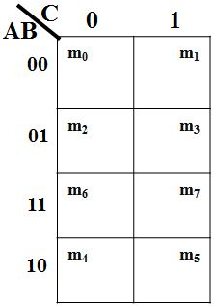 | 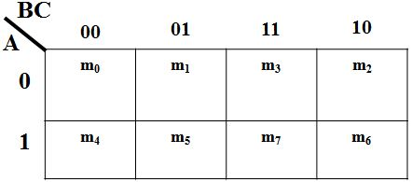
Moreover, we can make groups of 2, 4 & 8 cells having same 1s or 0s.
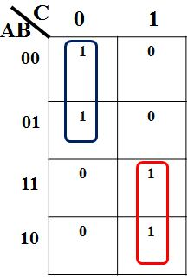 | 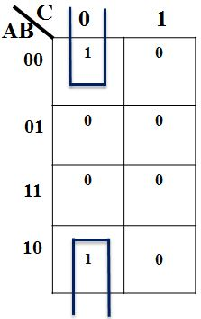
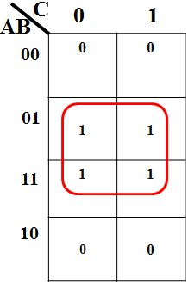 | 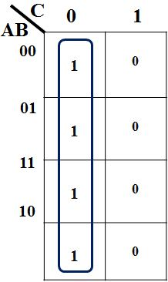

Example of 3 Variable K-Map:

Simplify the given function using K-map.
F (A, B, C) = ∑ (m₀, m₂, m₃, m₄, m₆, m₇)
Solution:
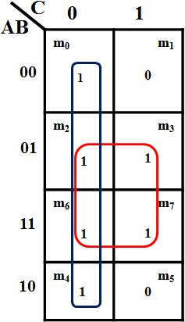
The sum of these two terms will make the simplified expression of the function as given below.
F = B + C̅

5.5 4-Variable K-Map

Four variables have 2^{n}=2⁴=16 minterms. So, a 4-variable k-map will have 16 cells as shown in the figure given below.
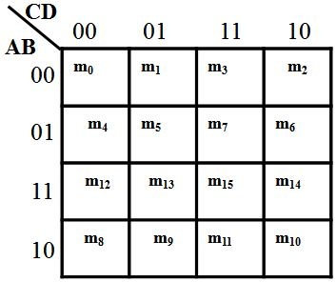

Each cell (min term) represents the variables in front of the corresponding row & column.
Some examples of grouping in 4-variable k-map are given below:
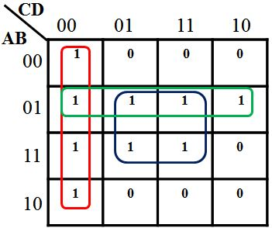 | 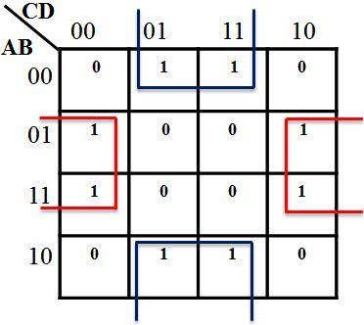

Example of 4 Variable K-Map:

Simplify the given function using K-map.
F (A, B, C, D) = ∑ (m₀, m₁, m₄, m₅, m₆, m₈, m₉, m₁₂, m₁₃)
Solution:

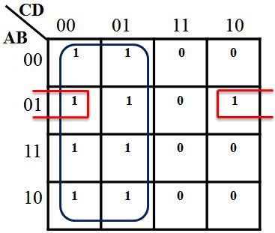

Group of 8 will give a term of 1 literal that remains unchanged i.e. C̅
So, the expression will F = C̅ + A̅BD̅
6. Binary Arithmetic:

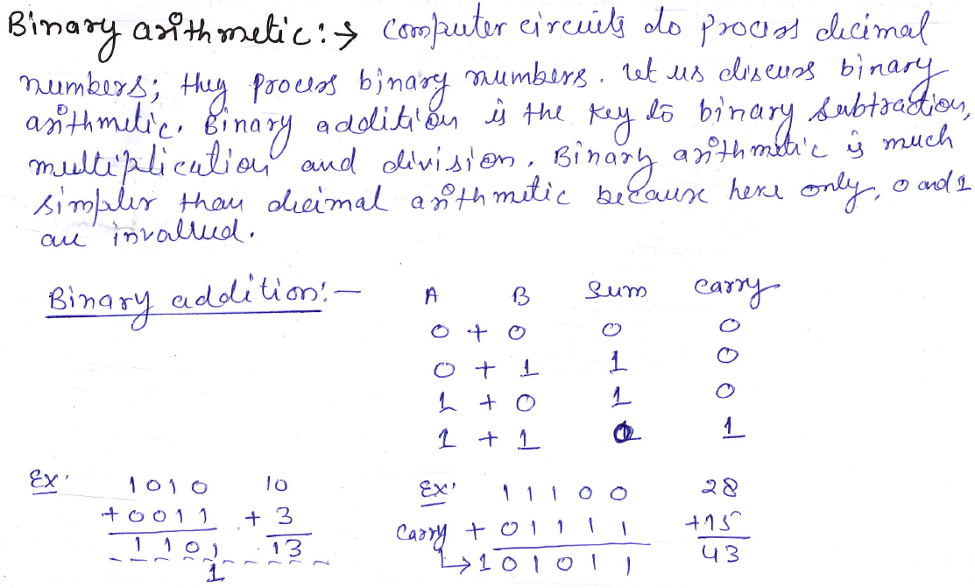

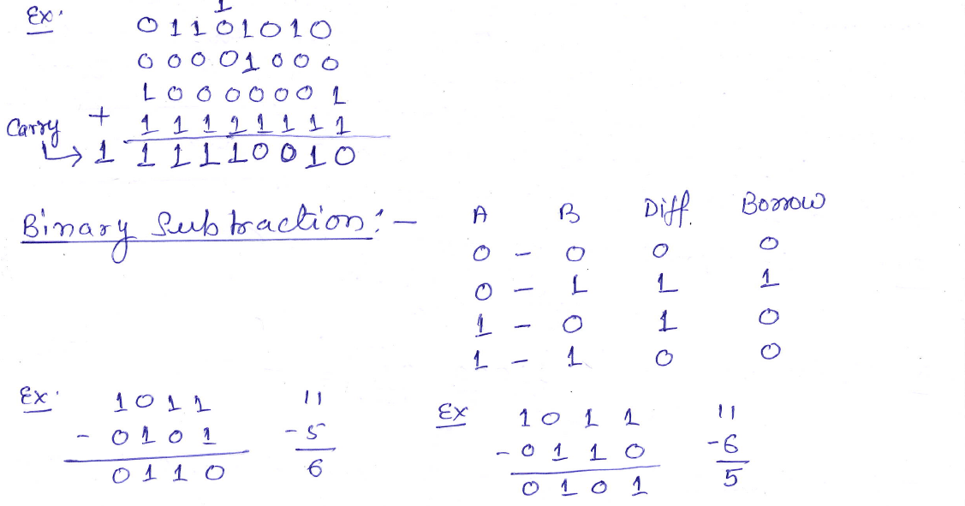

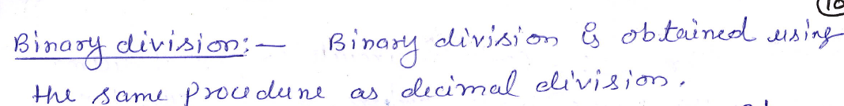

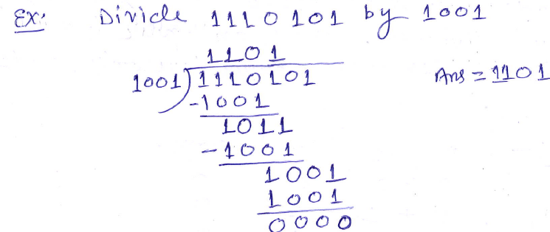

7. Complements

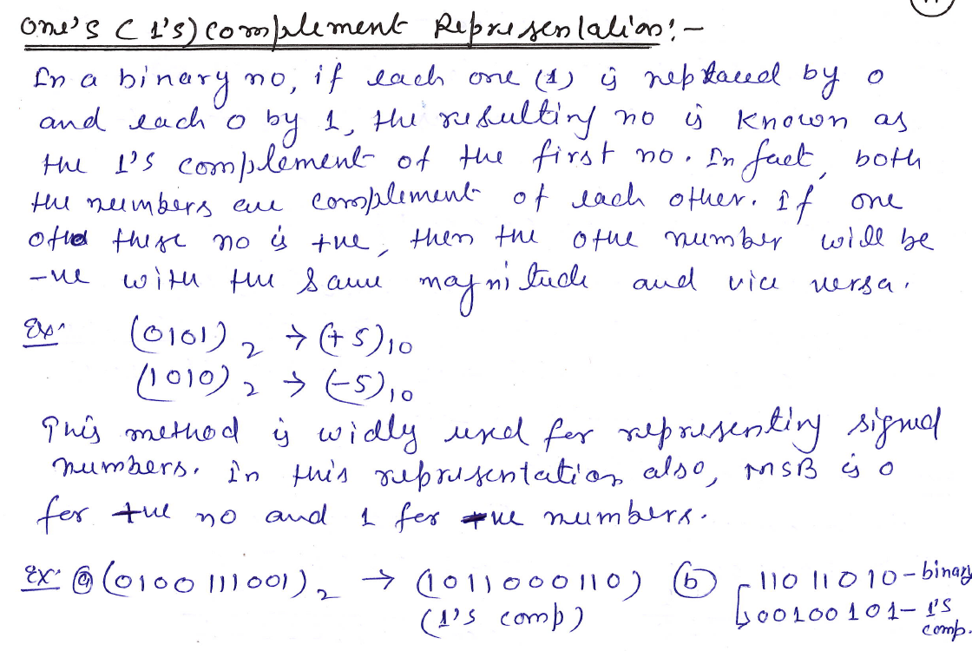
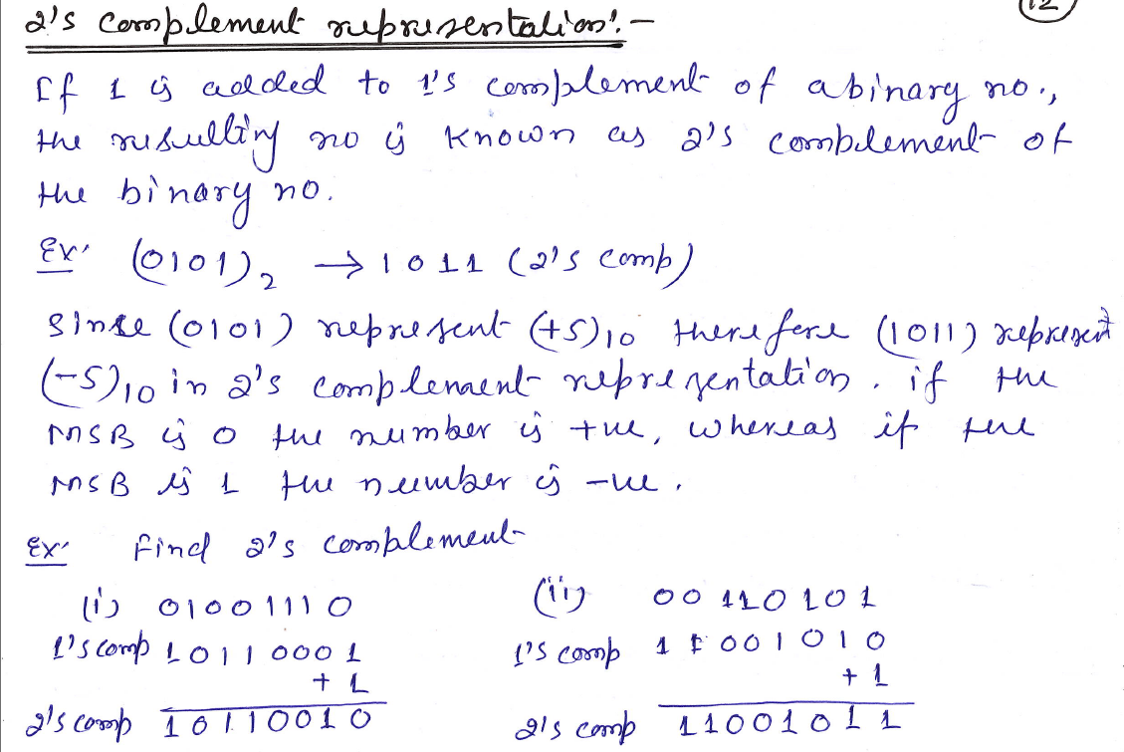

Binary Subtraction using Complements (1s & 2s)
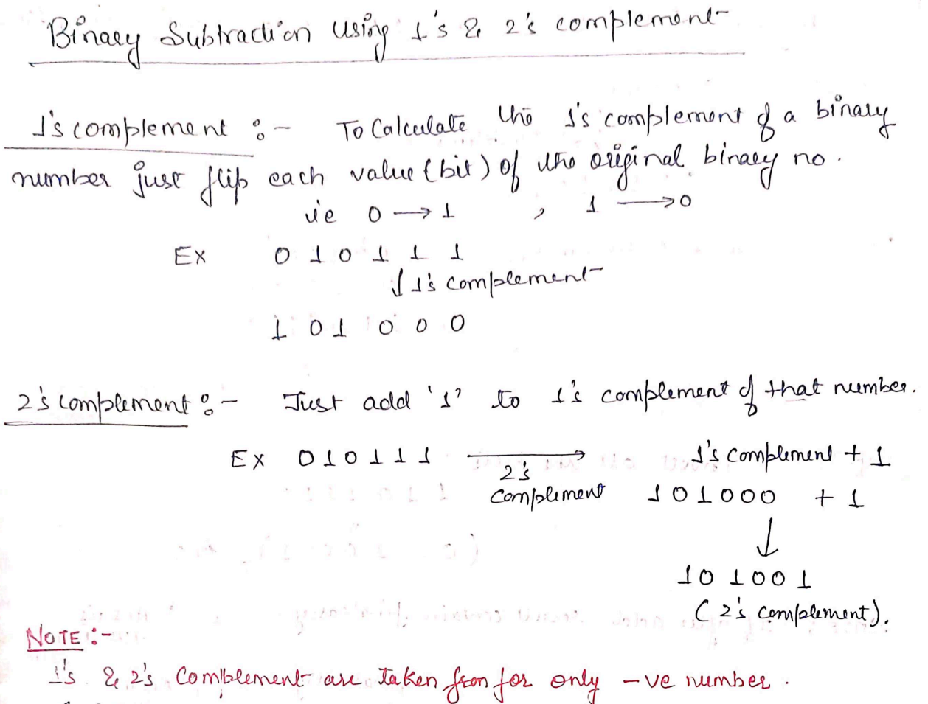

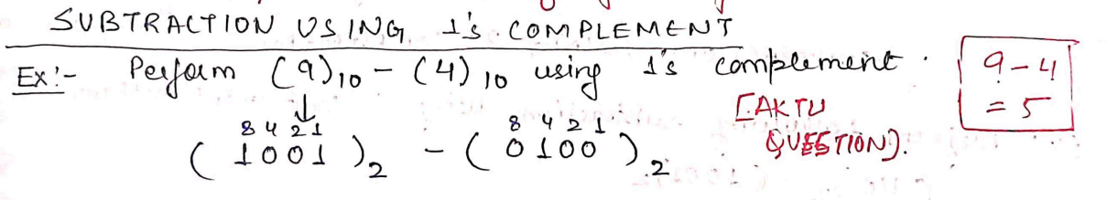

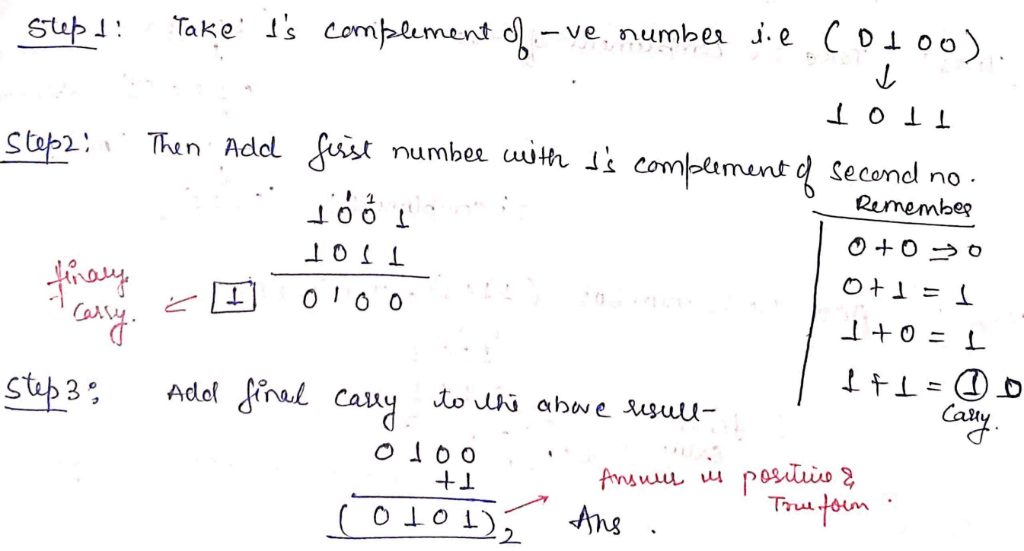

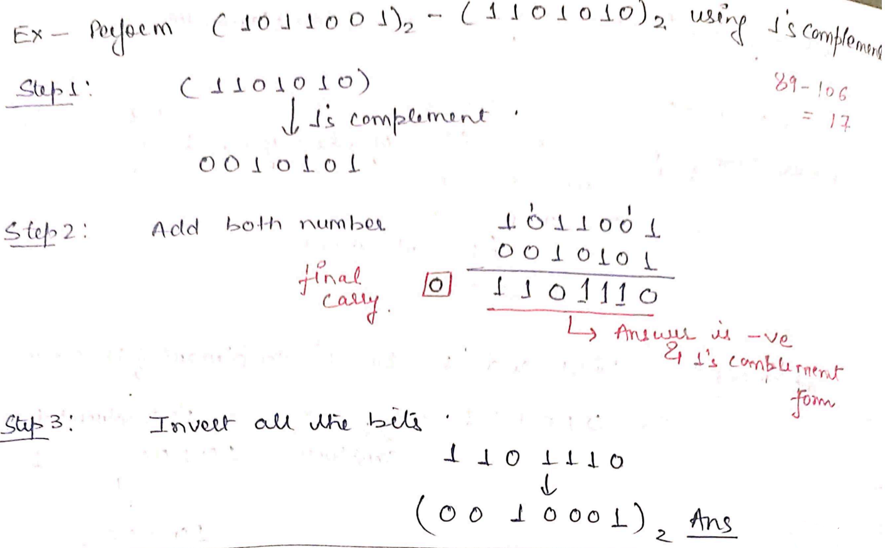

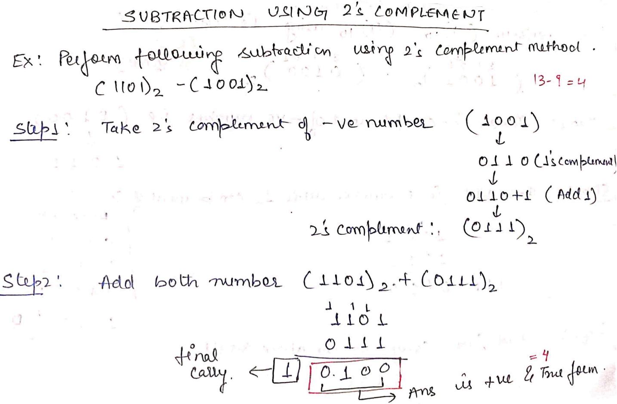

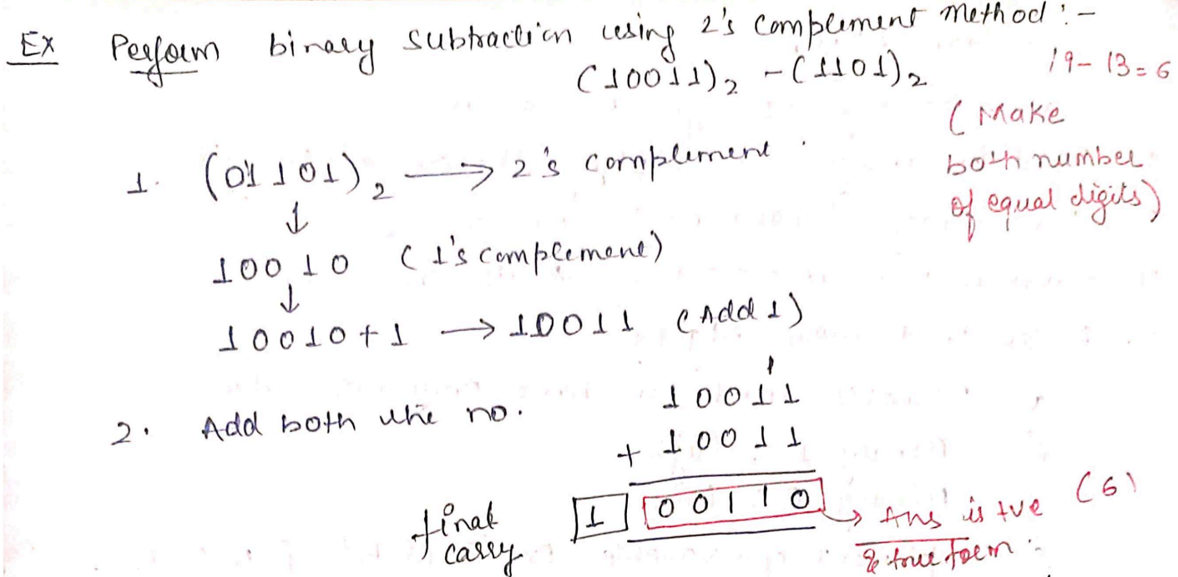

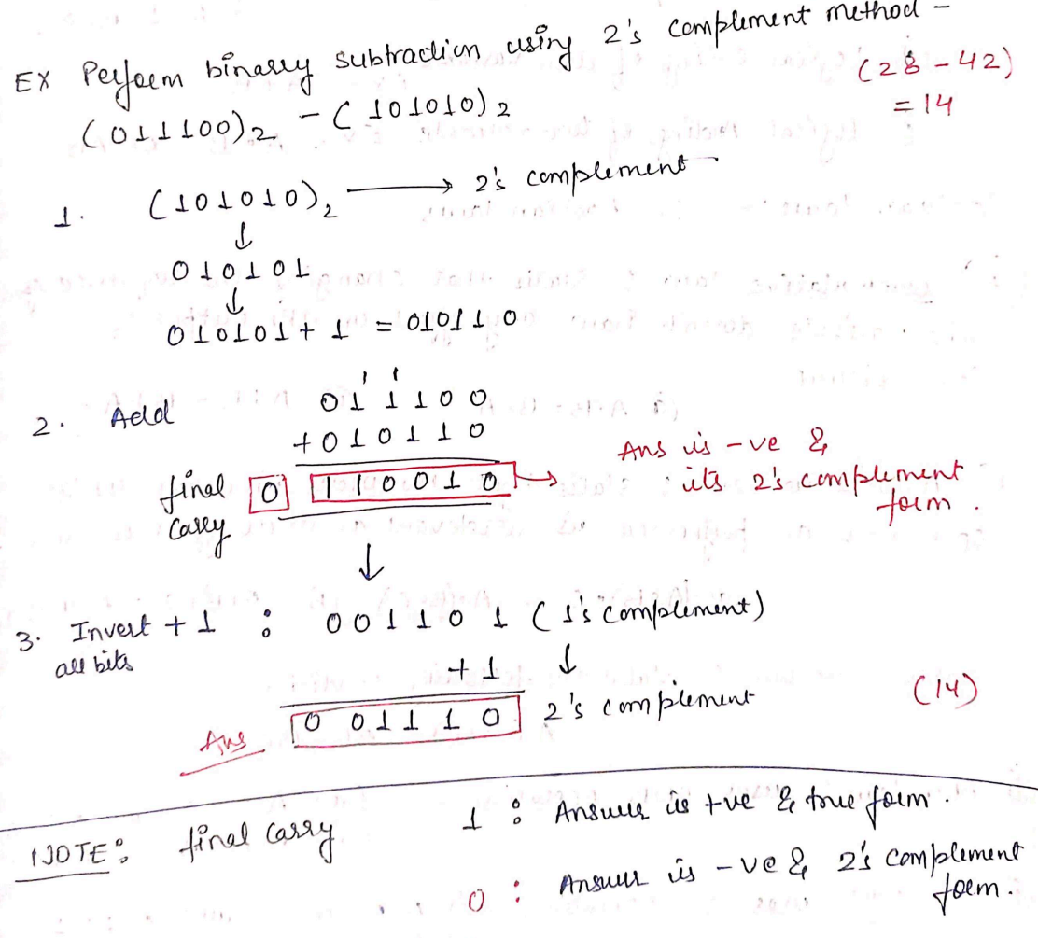

Codes (Weighted and Non-weighted codes, BCD & Gray Code)

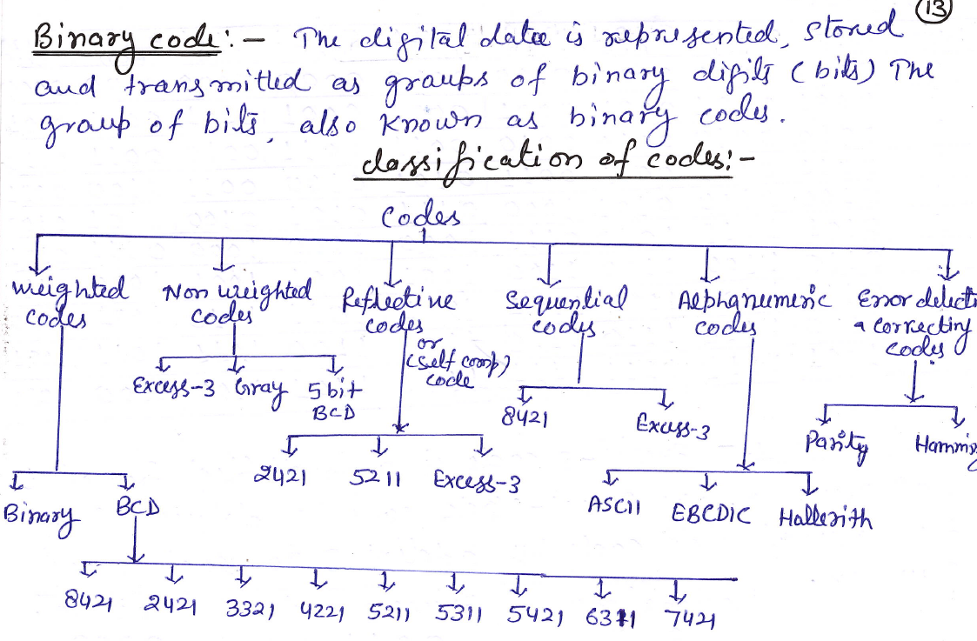
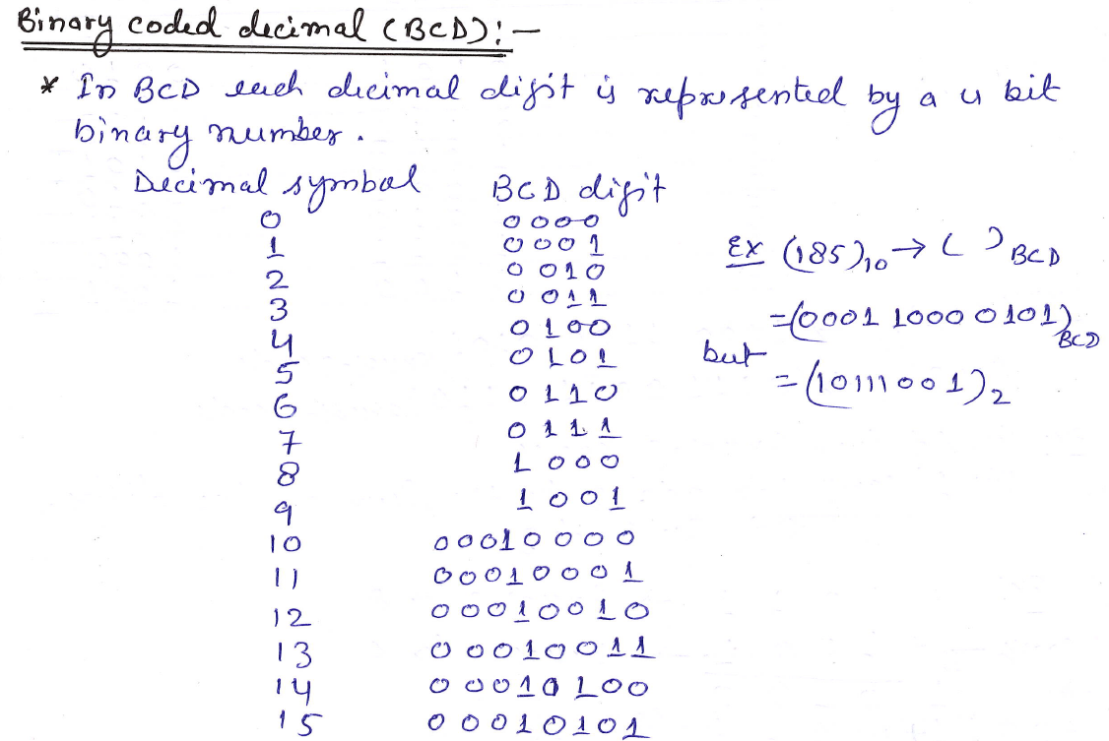
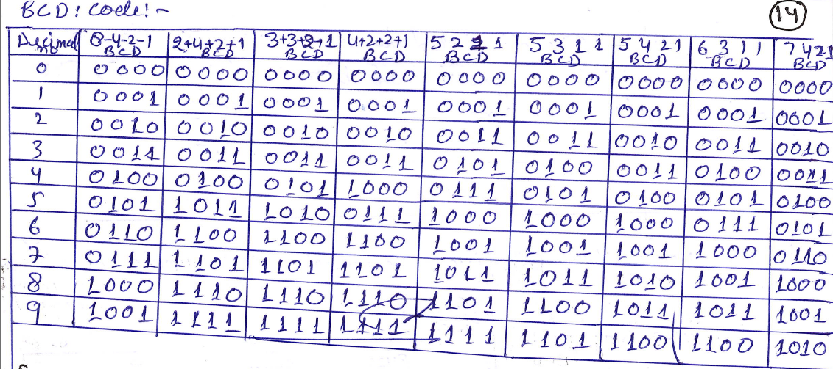
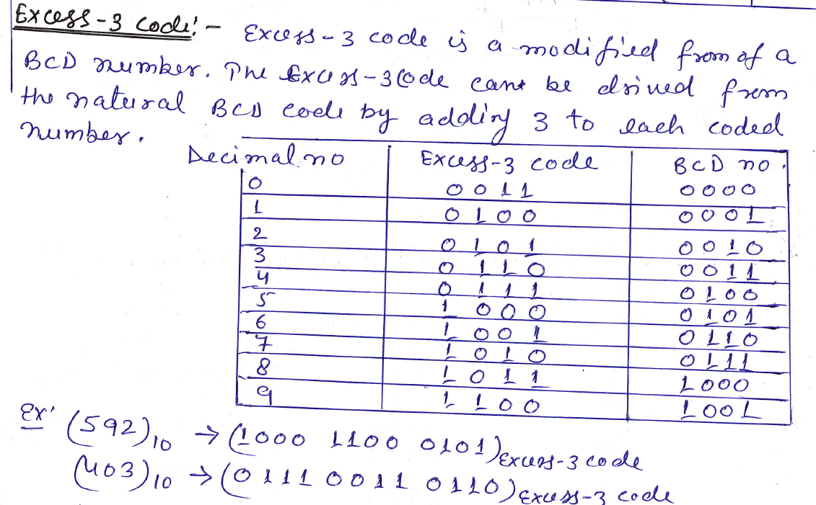
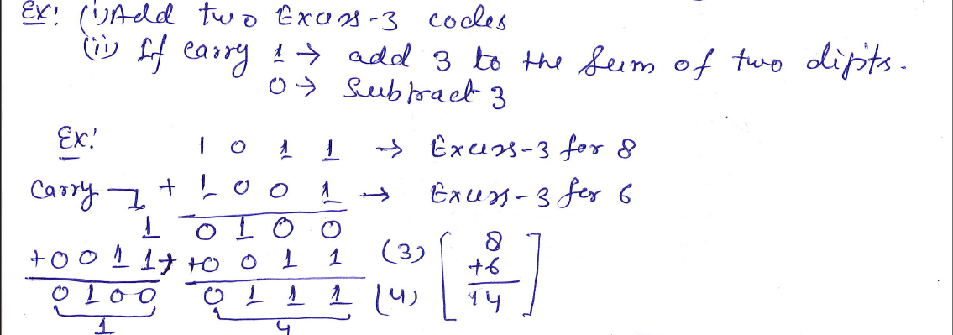
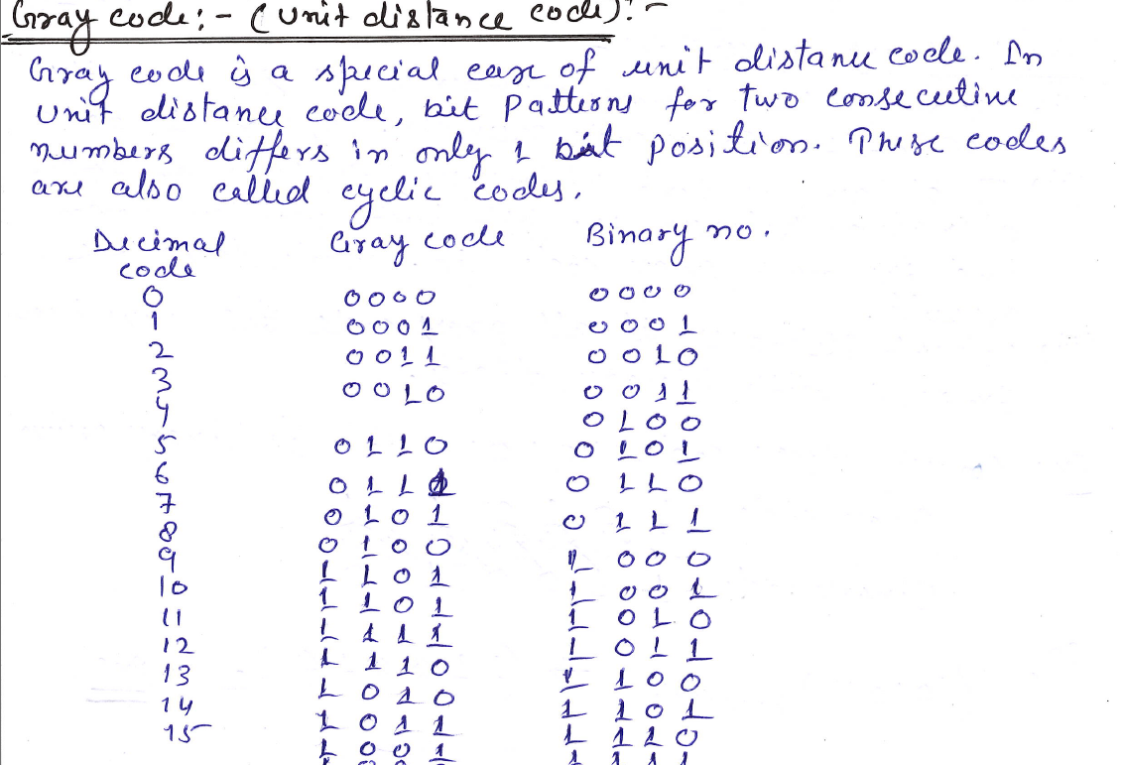
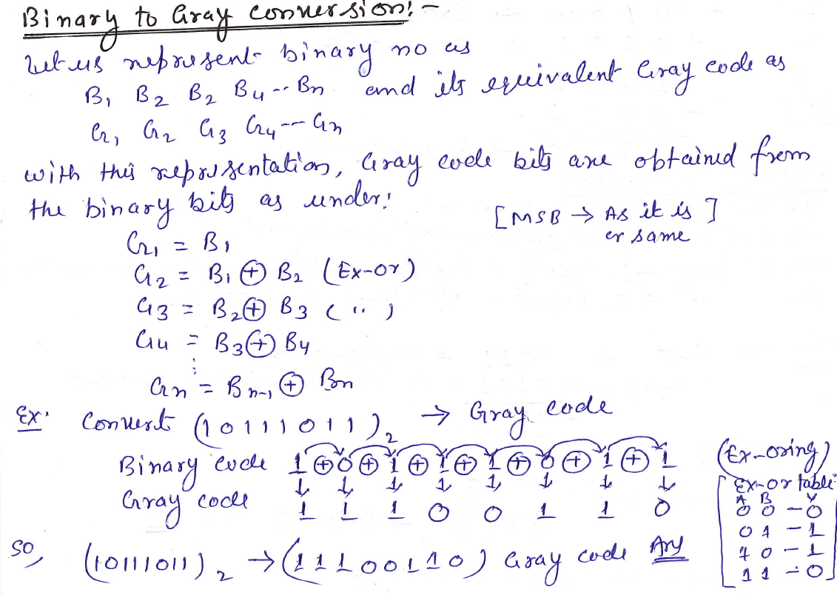
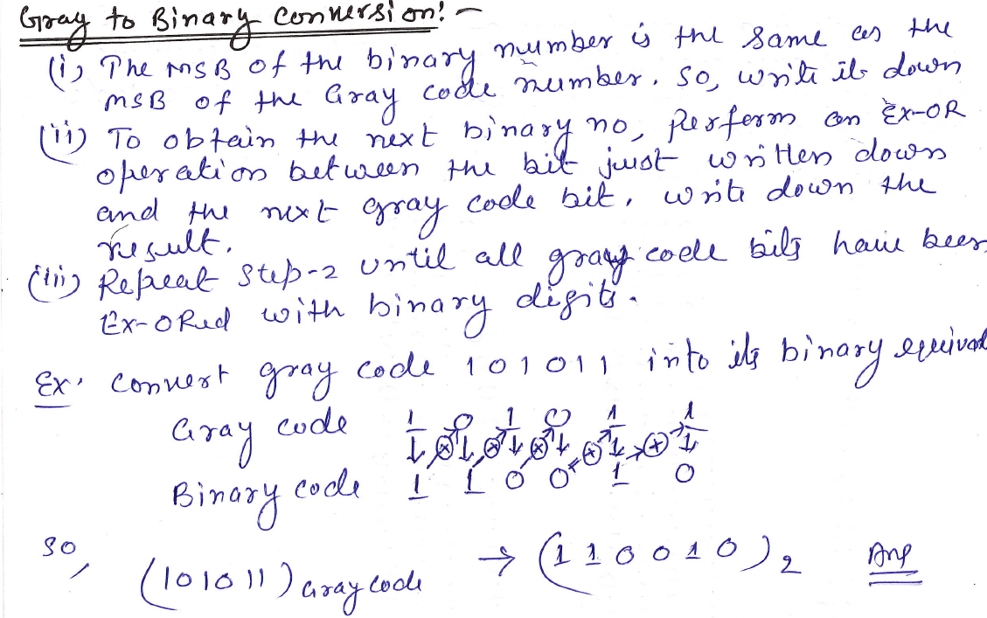

Sampling & Quantization in Digital Signal Processing
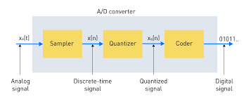

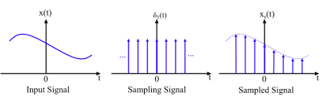

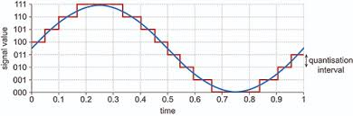

Sampling is the process of converting a continuous signal's domain (like time or space) into a discrete sequence of points, while quantization is the subsequent process of converting the signal's amplitude at those discrete points into a limited, finite set of digital values. Together, these two steps, performed by an analog-to-digital converter (ADC), transform analog signals into the discrete digital format required for digital processing, storage, and transmission.

9.1. Sampling
- Definition:
Sampling is the process of discretizing the domain of a continuous signal, such as taking measurements of a signal's amplitude at regular intervals in time or space.
- Purpose:
It allows for the representation of a complex, continuous signal as a sequence of numerical values, making it suitable for digital processing.
9.2. Quantization
- Definition:
Quantization is the process of converting the continuous amplitude values obtained from sampling into a finite number of discrete, predefined values or levels.
- Purpose:
It digitizes the range or amplitude of the signal, replacing the precise sampled real number with the closest value from a limited set of discrete choices.
In Summary
- Sampling: digitizes the signal's coordinate values (e.g., time, x-axis).
- Quantization: digitizes the signal's amplitude values (e.g., magnitude, y-axis).
- Both processes are essential for converting an analog signal into a digital one, with the accuracy and quality of the final digital signal depending on the sampling rate and the number of quantization levels used

Fundamentals and Applications of Quantum Computing and Edge Computing

Quantum Computing
Quantum computing is a type of computing that uses the principles of quantum mechanics, such as superposition, entanglement, and interference, to process information in a fundamentally different from classical computers.

Its basic unit of information is the qubit, which can represent both 0 and 1 simultaneously, enabling parallel computations that allow quantum computers to solve certain complex problems exponentially faster than classical computers.
Core Fundamentals:
- Superposition:
Unlike classical bits that are either 0 or 1, a qubit can be in a superposition of both states simultaneously. This allows a quantum computer to explore multiple possibilities at once.
- Entanglement:
This quantum phenomenon links two or more qubits so that their states are correlated, even when physically separated. Measuring the state of one entangled qubit instantly reveals information about the other, no matter the distance.
- Interference:
Quantum interference is used to manipulate the probability of different outcomes, reinforcing correct answers and cancelling out incorrect ones in a quantum computation.
Key Components
- Qubits:
The fundamental unit of quantum information. A system of k qubits can represent 2^k distinct states, providing exponential parallel processing power compared to k classical bits.
- State Vector:
The mathematical description of a quantum system's state, a vector where each component's squared magnitude represents the probability of observing a particular output.

- Measurement:
A quantum computation ends with measurement, which collapses the superposition state into a single classical outcome (a sequence of bits), chosen probabilistically according to the quantum state.
Quantum vs. Classical Computing
- Speed:
For certain complex problems, quantum computers offer a significant speed advantage, such as finding a secret key with O(√n) complexity compared to a classical computer's O(n) complexity.
- Applications:
Quantum computers are ideal for tasks like simulating complex physical systems (e.g., molecular behavior, protein folding), which are beyond the reach of even the most powerful classical supercomputers.

Applications of Quantum Computing
1. Cryptography
- Breaking classical encryption (via Shor's algorithm).
- Developing quantum-resistant algorithms (post-quantum cryptography).
- Quantum key distribution (QKD) for secure communication.
2. Quantum Simulation
- Simulating quantum systems (e.g., molecules, materials) that are intractable for classical computers.
- Applications in drug discovery, chemistry, and materials science.
3. Optimization Problems
- Solving complex combinatorial problems in logistics, finance, and operations research.
- Algorithms like Quantum Approximate Optimization Algorithm (QAOA) show promise.
4. Machine Learning
- Quantum machine learning (QML) models may speed up data analysis, classification, and pattern recognition.
- Algorithms like quantum support vector machines, quantum neural networks, etc.
5. Financial Modeling
- Risk analysis, portfolio optimization, and Monte Carlo simulations.
- Potential to improve speed and accuracy of financial predictions.
6. Artificial Intelligence
- Quantum-enhanced data processing and decision-making.
- Currently more theoretical, but research is advancing.

  - Edge Computing

Edge computing brings data processing and storage closer to the data's source, rather than sending all data to a central cloud or data center. This distributed architecture reduces latency, conserves bandwidth, enhances reliability by minimizing network dependency, and improves data privacy.

The fundamentals involve a layered approach, with devices generating data at the bottom layer, edge devices processing and reducing data at the middle layer, and the cloud for long-term storage and big data analysis at the top layer.
Core Principles
- Proximity:
The key principle is to perform computation as close as possible to the data source, at the "edge" of the network.
- Decentralized Processing:
Instead of a single, centralized cloud, computing resources are distributed across numerous edge devices and local gateways.
- Local Data Handling:
Data is processed, filtered, and analyzed at the edge, with only essential results or summaries sent to the cloud.
Benefits
- Lower Latency:
Reduced distance between data sources and processing centers leads to faster response times for time-sensitive applications.
- Reduced Bandwidth Costs:
By processing and filtering data locally, the volume of data sent over the network to the cloud is significantly reduced, saving bandwidth and costs.
- Increased Reliability:
Applications can continue to operate even with intermittent or limited network connectivity, as processing occurs locally.
- Enhanced Security and Privacy:
Sensitive data can be processed and anonymized at the edge, reducing the risk of exposure during transmission to the cloud.
- Improved Performance:
Local processing allows for real-time insights and faster, data-driven decision-making.
Architecture
An edge computing architecture typically includes:
- Device Layer:
End-user devices, smartphones, IoT sensors, and computers that generate data.
- Edge Layer:
Edge gateways and small servers that perform local data processing, filtering, and caching.
- Cloud Layer:
Centralized servers for large-scale data storage, complex analysis, and long-term data warehousing.

Applications of Edge Computing
1. Internet of Things (IoT)
- Local processing in smart sensors and devices.
- Reduces the need for constant cloud connectivity.
Examples:
- Smart thermostats
- Industrial IoT (IIoT) in factories

2. Autonomous Vehicles
- Real-time data processing from cameras, LIDAR, and radar.
- Decisions (e.g., braking, obstacle avoidance) must happen in milliseconds.

3. Healthcare
- Edge-enabled medical devices for real-time monitoring (e.g., wearables).
- Faster decision-making in critical scenarios like ICU or emergency rooms.
4. Retail
- Smart shelves and cameras analyze customer behavior in real-time.
- Edge systems can manage inventory, digital signage, and POS systems.

5. Smart Cities
- Edge computing supports traffic management, surveillance, and environmental monitoring.
- Enables quick decision-making based on real-time data.

6. Manufacturing (Industry 4.0)
- Predictive maintenance using local data analytics.
- Quality control and machine optimization at the edge.

7. Augmented Reality (AR) / Virtual Reality (VR)
- Real-time rendering for immersive experiences.
- Used in gaming, remote collaboration, and training.

8. Content Delivery & Streaming
- Edge servers cache and deliver content locally to reduce latency.
- Improves user experience for video streaming, gaming, etc.

Edge computing is essential for enabling low-latency, high-efficiency computing in environments where cloud dependence is impractical or inefficient. Its synergy with IoT, AI/ML, and 5G makes it foundational for the future of connected and intelligent systems.

- Summary of the Unit

- This unit introduces the principles and applications of digital electronics, covering key topics such as number systems, binary arithmetic, Boolean algebra, logic gates, and combinational and sequential circuits.
- These concepts are essential for understanding the operation and design of digital devices. The unit begins with an exploration of various number systems, including binary, octal, and hexadecimal, and their conversions, which are crucial for digital computation. It then delves into binary arithmetic operations such as addition, subtraction, multiplication, and division.
- Boolean algebra is introduced as the mathematical foundation for digital logic, along with theorems and properties that facilitate the simplification of logical expressions. The unit also examines logic gates, including AND, OR, NOT, NAND, NOR, XOR, and XNOR gates, and their truth tables.
- It also discusses about the simplification of Boolean Expressions using K-Map (upto 4 variables) and the implementation of the solution using NAND and NOR gates.
- This unit also has a brief introduction to damping and quantization in digital signal processing i.e. the conversion from analog to digital signal.
- Moreover, it also focusses on the latest technologies of Edge computing and Cloud computing.

- Previous Year University Questions

  - Short Questions with Answer

- What is a Logic gate?
Answer: A logic gate is a basic building block of digital circuits that performs a specific logical operation (like AND, OR, NOT) on one or more binary inputs to produce a single binary output.

- What is DeMorgan’s theorem?
Answer: DeMorgan's Theorem provides two transformation rules for simplifying Boolean expressions:
- (A · B)' = A' + B'; The complement of a product is equal to the sum of the complements.
- (A + B)' = A' · B’; The complement of a sum is equal to the product of the complements.

- Define minterms and maxterms.
Answer:
Minterm: A minterm is a standard product (AND) term in Boolean algebra where each variable appears exactly once, either in its true or complemented form. It corresponds to a single row in the truth table where the function is 1.

Maxterm: A maxterm is a standard sum (OR) term in Boolean algebra where each variable appears exactly once, either in its true or complemented form. It corresponds to a single row in the truth table where the function is 0.

- What are universal gates? Why are they called so?
Answer: Universal gates are logic gates (NAND and NOR) that can be used to implement any other basic gate (AND, OR, NOT) and, therefore, any digital circuit.
They are called “universal” because their versatility allows the construction of any logic function using only one type of gate.

- What is the use of don’t care combinations? Is it an advantage or disadvantage to include them in a map?
Answer: Don't care combinations are input conditions in a truth table where the output does not affect the circuit's functionality. They are used in Karnaugh maps (K-maps) to simplify Boolean expressions by treating them as either 0 or 1, whichever minimizes the circuit. Moreover, Including don't care combinations helps in optimizing the circuit, reducing the number of gates and complexity.

- Distinguish between SOP and POS.
Answer: SOP (Sum of Products) and POS (Product of Sums) are two standard forms of representing Boolean expressions.
In SOP, the expression is written as a sum (OR) of product (AND) terms, derived from truth table rows where the output is 1
Example: F = AB + A'CF=AB+A′C
POS represents the expression as a product (AND) of sum (OR) terms, derived from rows where the output is 0
Example: F = (A + B) (A' + C)

  - Previous Year Numericals with Solution (AKTU)

- Convert the following to the corresponding bases [AKTU, 2020-21, 2021-22]

- (73.12)₁₀= ( )₂

- (110110.011)₂= ( )₁₆

- (231.36)₁₀= ( )₂

- (11011.10)₂= ( )₁₀

- (6FB.67)₁₆= ( )₁₀

- (437)₈= ( )₁₀

- (1110111.11011)₂= ( )₈

- (1011.10110)₂= ( )₁

- (743.15)₈ = ( )₂

- (9AC.1B)₁₆= ( )₂

Solution:
i.
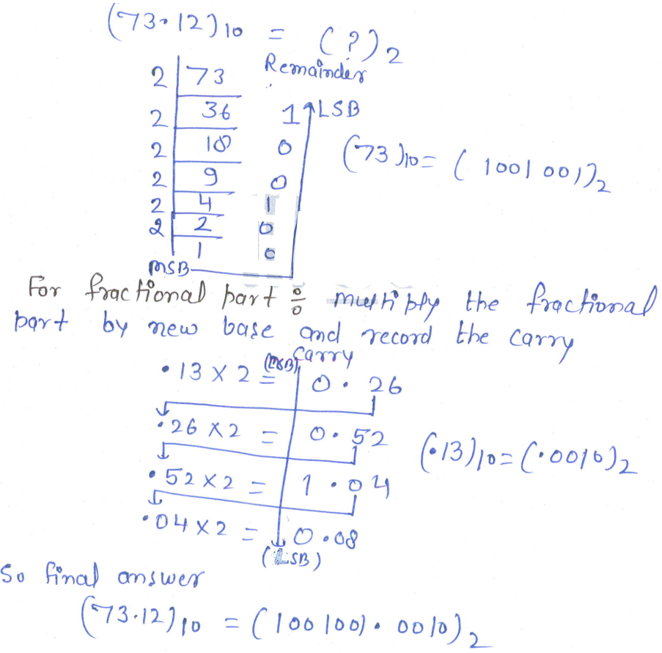

ii.
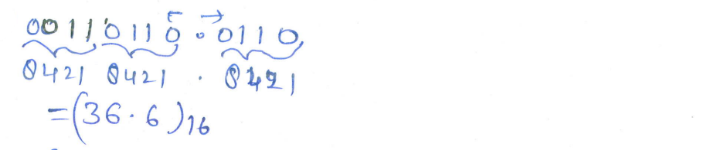

iii.
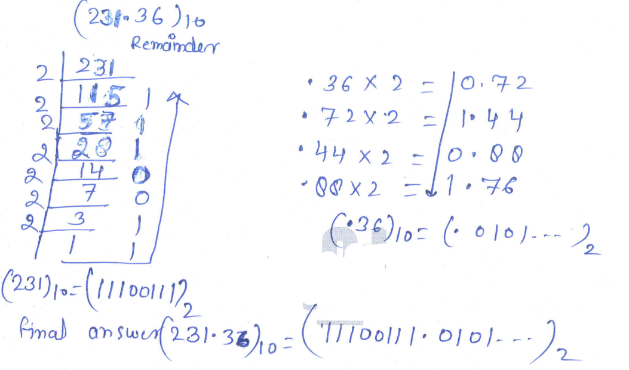

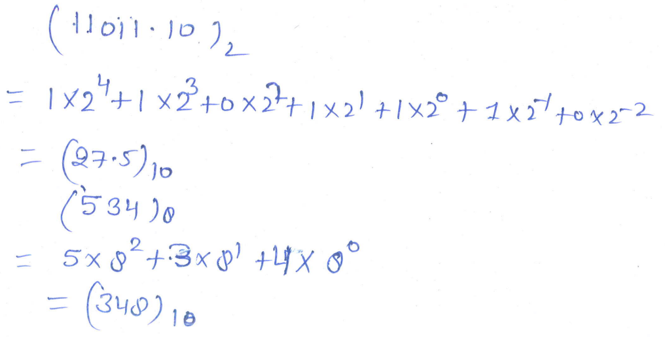

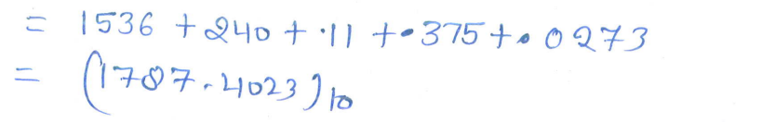

iv.
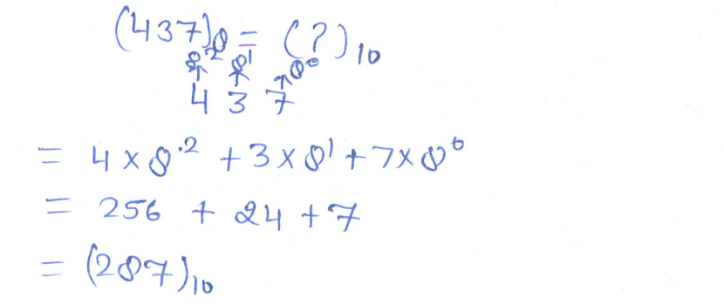
v.
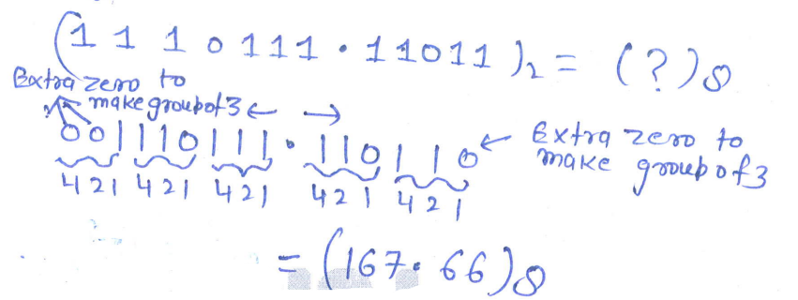

vi

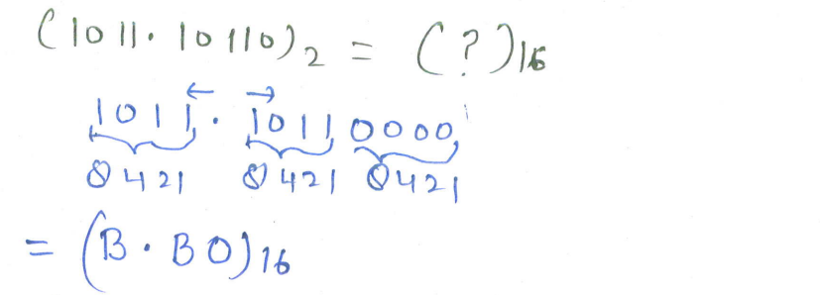

vii.

viii.
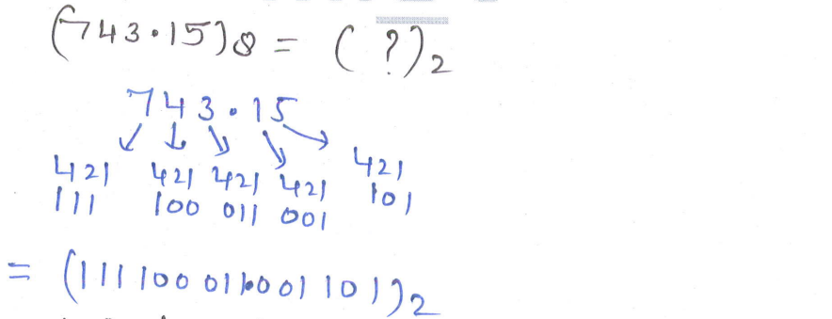

ix.
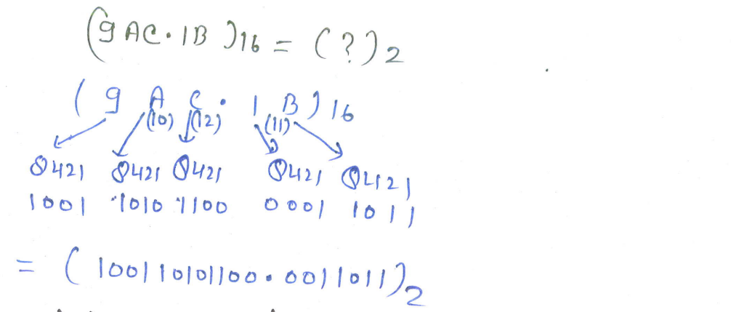

- Using K-map method, determine the minimal POS expression for the following using decimal notation F (A, B, C, D) = πM (3,4,5,7,9,13,14,15). d (0, 2, 8). Also, implement using NOR gates only. [AKTU, odd sem, 2021-22]

Solution:
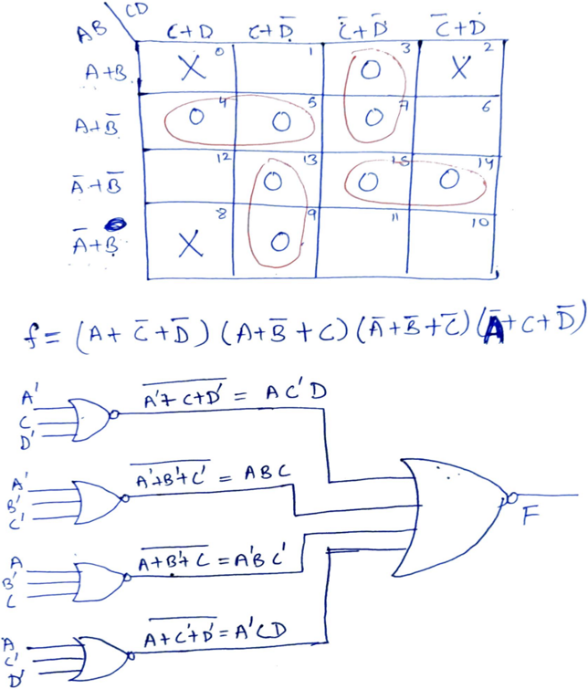

- Simplify the expression F(a,b,c,d,e)=∑m(0,1,2,4,5,6,10,13,14,18,21,22,24,26,29,30) using K-map. Also, implement using logic gates. [AKTU, odd sem, 2021-22]

Solution:

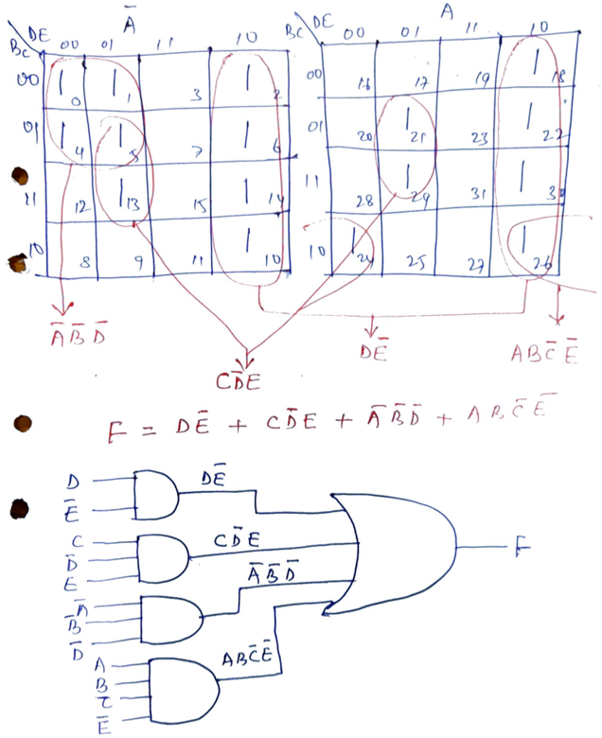

- Simplify the following function using K map:
f (V, W, X, Y, Z) = ∑m (0,7,8,9,12,13,15,16,22,23,30,31). [AKTU, even sem, 2022-23]
Solution:

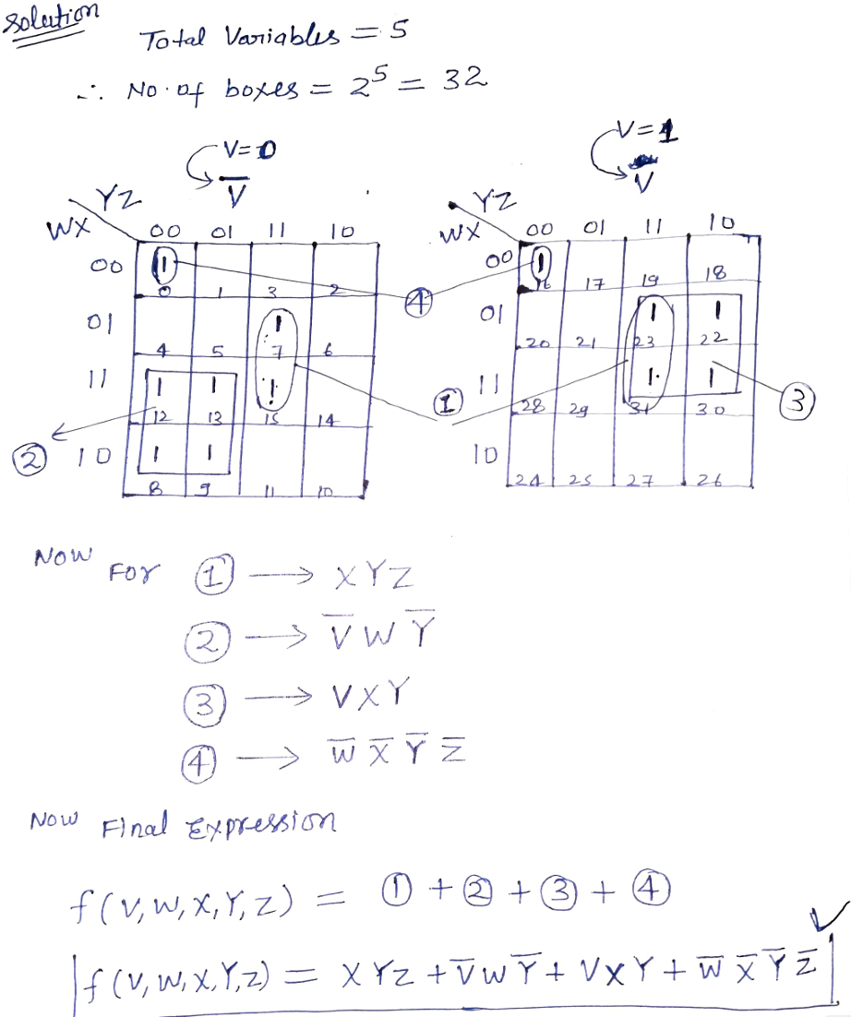

- Simplify the following function using K map and implement the simplified function using NOR gate only F (A, B, C, D) = πM (1,3,4,5,6,7,11,12,14,15). [AKTU, even sem, 2022-23]

Solution:

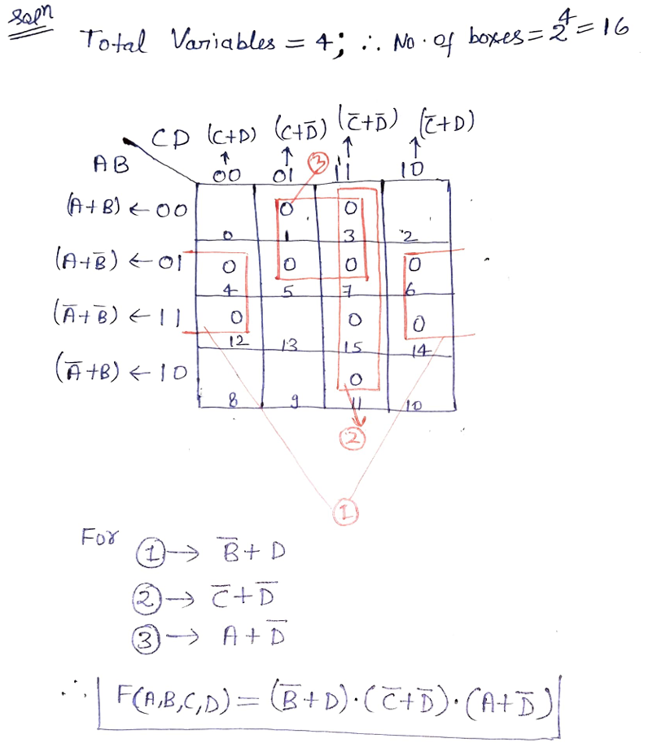

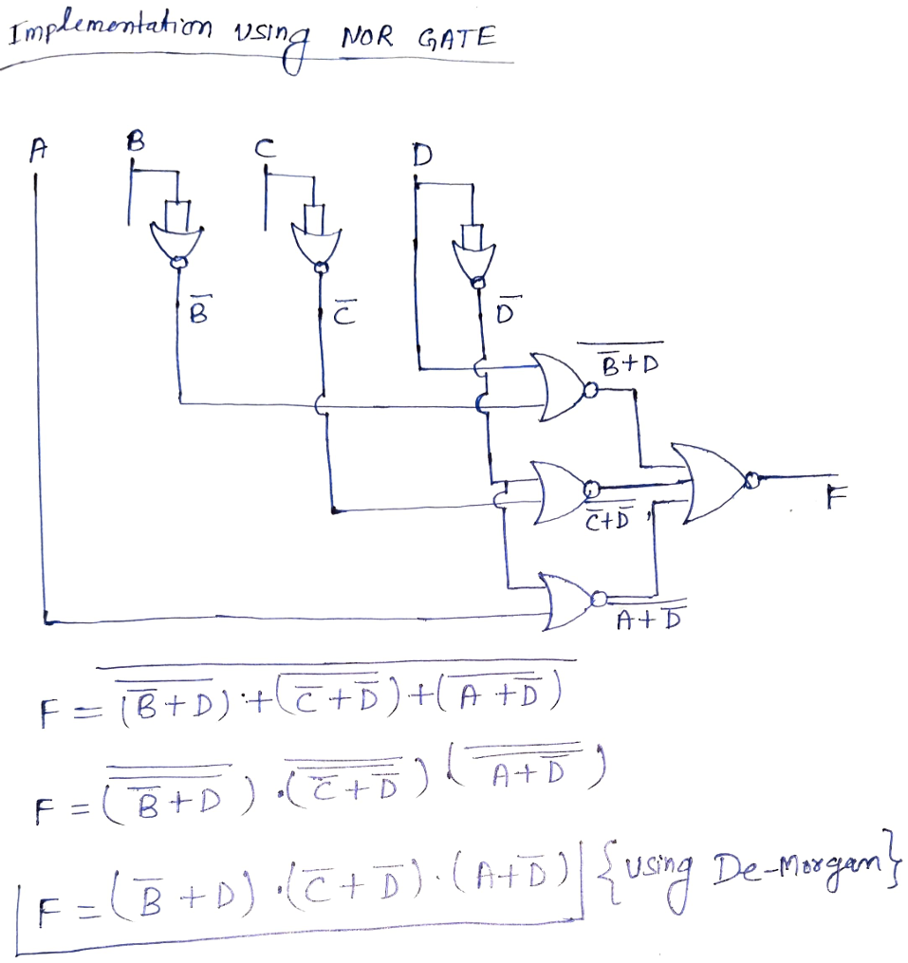

- Simplify the following using K-map. F (A, B, C, D) = Σ m (3,5,9,11,15) + d (2,4,6,10). [AKTU, odd sem, 2011-12]
Solution:

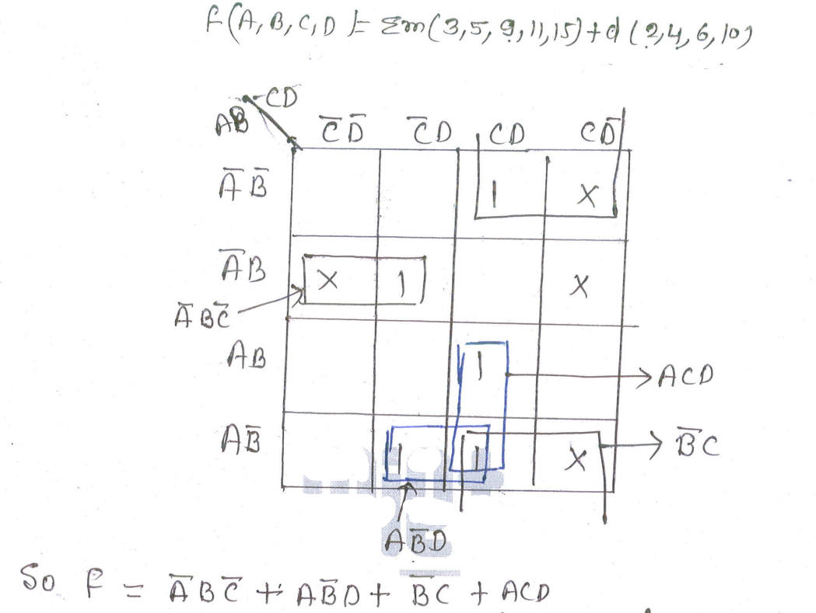

- Reduce the following function using K-Map. Also, implement with basic gates only.
F (A, B, C, D, E) = Σm (1,3,4,5,6,7,9,11,13,15). [AKTU, odd sem, 2020-21]
Solution:

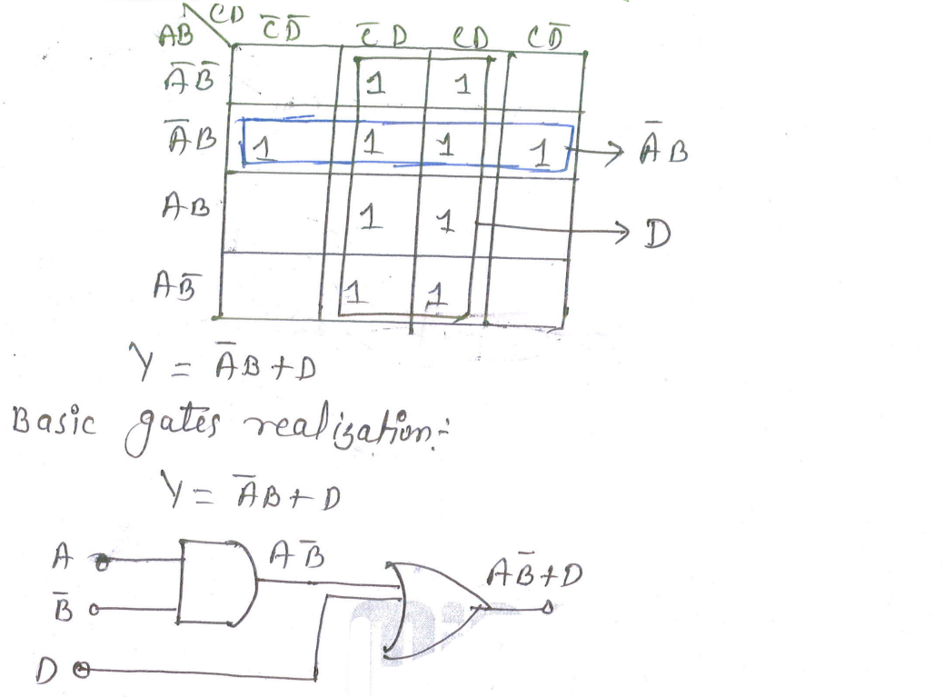

- Simplify following logic expression using K-Map and realize using NOR gates only.
F (A, B, C, D, E) = $\overline{A}\overline{ B}\overline{C}+A \overline{C}\overline{D}+A \overline{B}+ABC\overline{D}+\overline{A}\overline{B} C$. [AKTU, even sem, 2013-14]

Solution:

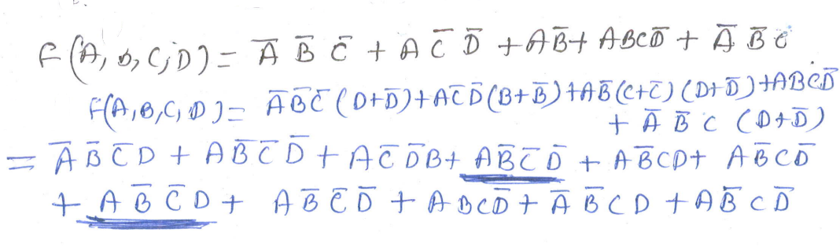
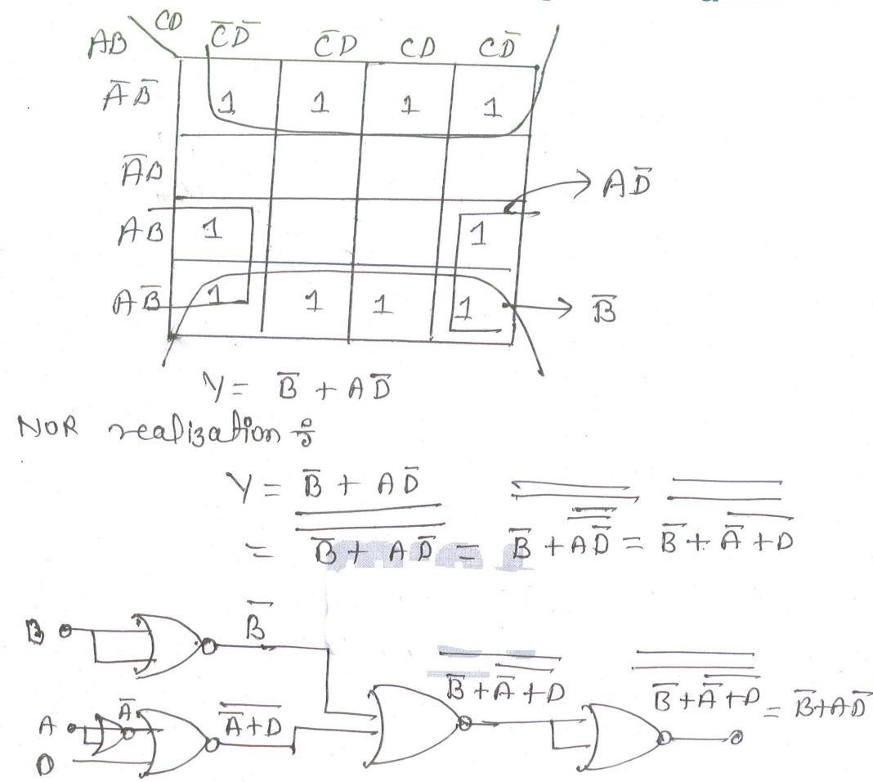

- Minimize the following using K-map:
F (A, B, C, D) = AB’C’ +A’BC + A’B’CD +ABCD + d (1,5). [AKTU, odd sem, 2011-12]

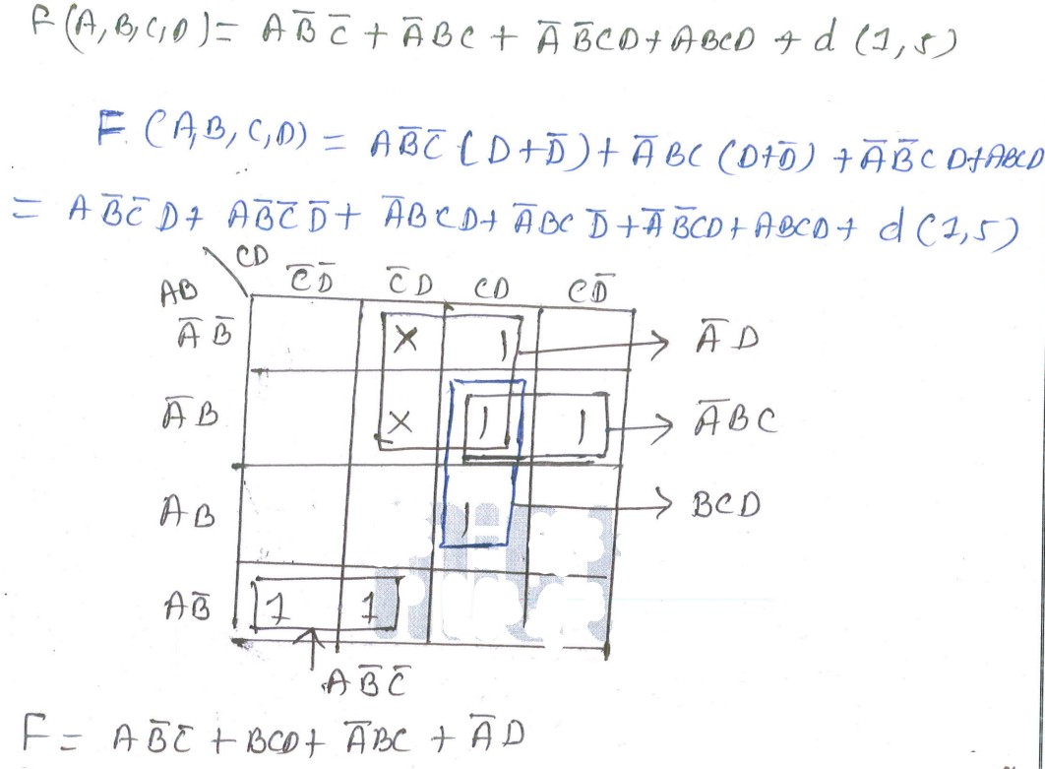

10. Implement EX-OR and EX-NOR gates using minimum NAND gates.

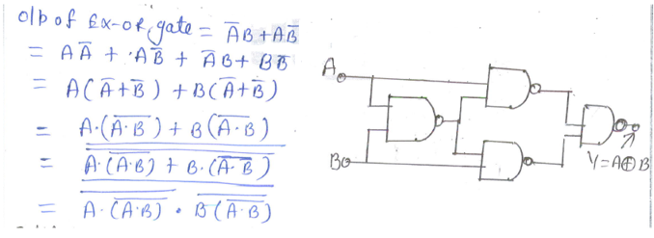

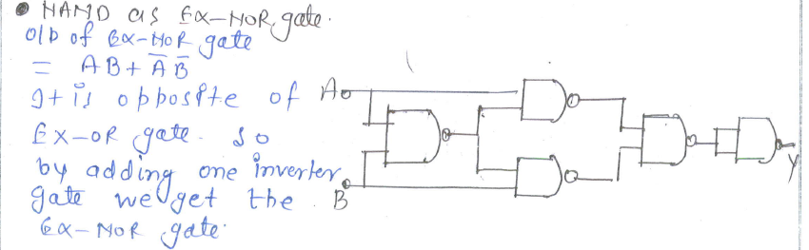

11. Implement EX-OR and EX-NOR gates using minimum NOR gates.

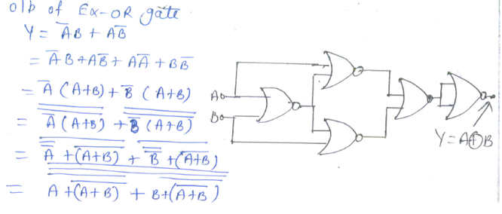

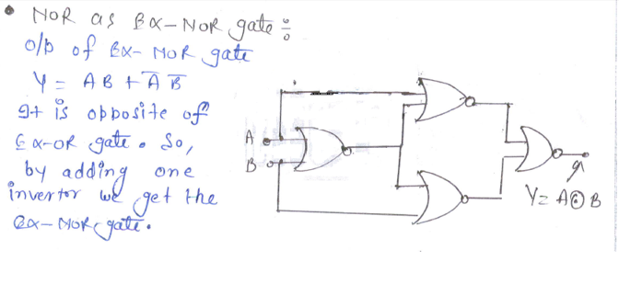
12. Define Universal Gates. Implement AND, OR, NOR by using NAND gates only.

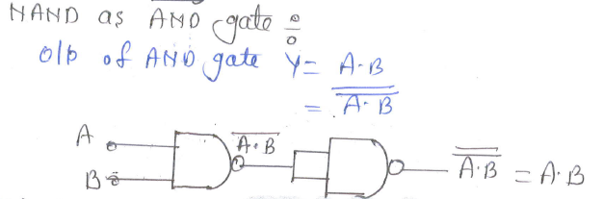
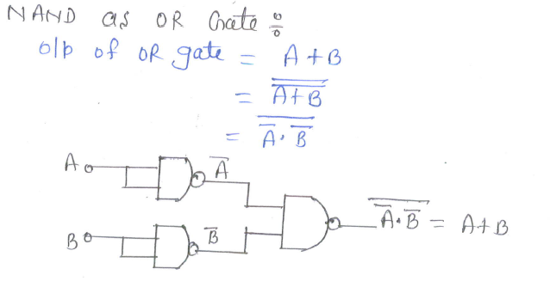
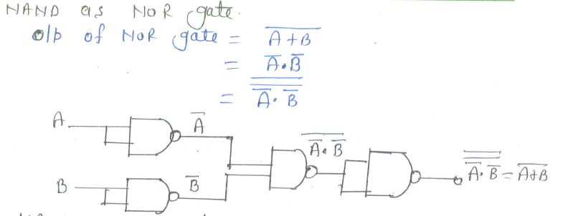

- Model Long Theory and Numerical Questions

- Define Universal Gates. Implement NOT, AND, OR, and NAND gates using NOR gates only. [Refer to 3.5]

- Using K-map method, determine the minimal POS expression for the following using decimal notation F (A, B, C, D) = πM (3,4,5,7,9,13,14,15). d (0, 2, 8). Also, implement using NOR gates only. (Hint: Given 4-variable K-map)

- Implement EX-OR and EX-NOR gates using minimum NAND gates [Refer to 3.5]

- Perform the following conversions:
- Y= (A+B) (A+C) (B+C), convert into standard POS form. (Hint: Include missing binary variables in each term using OR law)
- Y= AC+$\overline{A} \overline{B} C$+ $A \overline{C} \overline{D}$, convert into standard POS form. (Hint: Include missing binary variables in each term using AND law)

- Simplify the following using K-map.
F (A, B, C, D) = Σ m (13,15,17,18,19,20,21,23,25,27,29,31) + d (1,2,12,24). Also, implement using NAND gate only. (Hint: Given 5-variable K-map)

- Define Universal Gates. Also, realize AND, OR, and NOR gates using NAND gates only. [Refer to 3.5]

- Realize EX-OR and EX-NOR gates using minimum NOR gates. [Refer to 3.5]

- Describe the fundamentals and applications of Quantum Computing.

- Describe the fundamentals and applications of Edge Computing.

- Explain how an analog signal is converted to digital signal.

xxxxxxxxxxxxxxxxxxxxxxxxxxxxxxxxxxxxxxxxxxxxxxxxxxxxxxxxxxxxxxxxxxxxxxxxxxxxxx

